B01/0

**CHRISTMAS TREES**

Page 1 of 2

Area - Description

Responsibility For Cleaning

Engineering Assistance Req.

Responsibility For Inspection

Wholesale Butchery - Christmas Trees

Hygiene Operative

No

Hygiene Supervisor

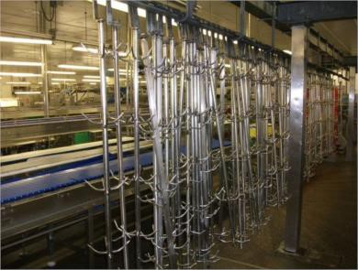

|  |  |  |
| --- | --- | --- |
| **USE PRODUCT COLOUR MINIMUM USE RATE**  **NAME CODE CONTACT** |  | **CLEANING TOOLS REQUIRED** |



**CHLORFOAM**

**PLUS**

**Detergent**

**% to 5%**

**3**

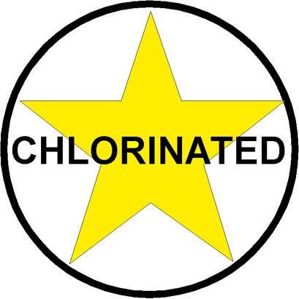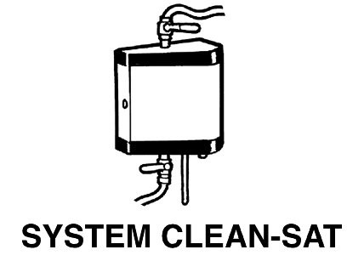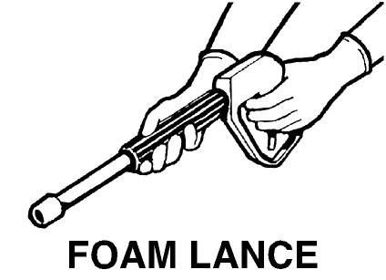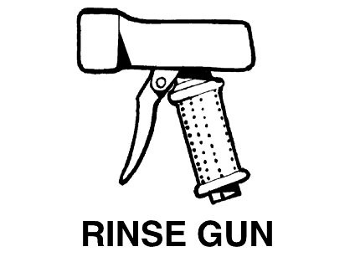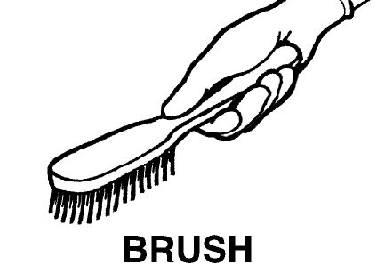

**mins**

**20**



**Disinfectant**

**ACTIVE**



**1**

**% to 1.3%**

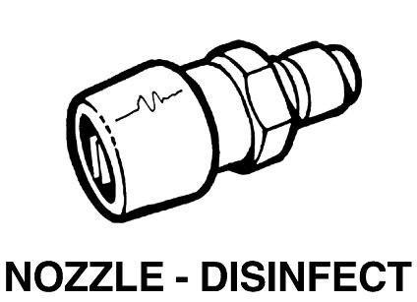

**15**

**Mins**



**Detergent**

**HOLFOAM ACID**

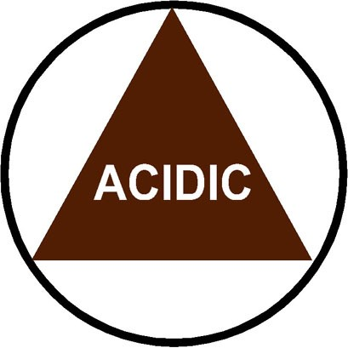

**3**

**% to 5%**



**20**

**mins**



**OTHER CONTROLS**

**PERSONAL PROTECTIVE EQUIPMENT**

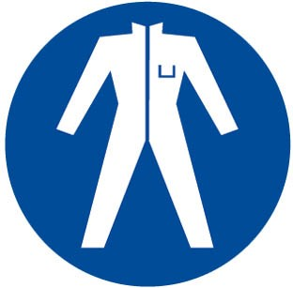

**SPECIAL PRECAUTIONS**

1. **Chlorfoam Plus** to be replaced with **Holfoam Acid** on a weekly basis when instructed by the Hygiene Manager.

# DAILY CLEANING METHOD

1. Collect a group of Christmas Trees. Do not remove from rail system and take care around rail system when cleaning Christmas trees as not to remove grease from the rail system.
2. Remove any gross debris and place in a grey / red colour coded tray for category 2 waste or a tray marked category 2 floor waste tray and then into a category 2 waste dolav.
3. Rinse all surfaces using fresh clean water to remove any remaining debris.
4. Apply **Chlorfoam Plus** detergent foam solution to all surfaces ensuring an even coverage.
5. Allow a minimum of 20 minutes contact time.
6. Whilst **Chlorfoam Plus** detergent solution is in contact, scrub any stubborn soiling using a designated blue scrubbing brush for the area.
7. Pay particular attention to hook tips and framework.
8. Rinse all surfaces thoroughly using fresh clean water.
9. Visually inspect to ensure all surfaces are clean and free from debris.
10. Reclean if necessary.
11. Spray disinfect all surfaces using **Active** solution.
12. Allow a minimum 15 minutes contact time.
13. Ensure document HYGBU/001 (Butchery Daily Hygiene Pre Op Sheet) is completed at the end of the shift.

|  |
| --- |
| Cleaning Instruction Card © |
| **CHRISTMAS TREES** |

B01/0

Page 2 of 2

**Photo No.**  1

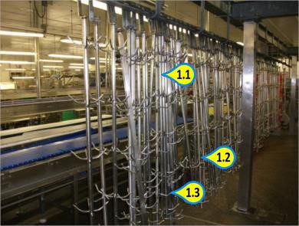**Key Inspection Points**

* 1. Framework
  2. Hook Tips
  3. Hook Tips

Area - Description

Responsibility For Cleaning

Engineering Assistance Req.

Responsibility For Inspection

Wholesale Butchery - Interlux Conveyors 1-10 & Extension Line Conv

Hygiene Operative

Yes

Hygiene Supervisor

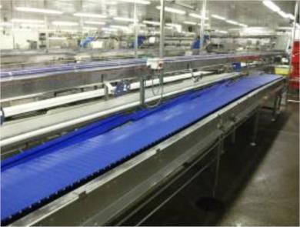

|  |  |  |
| --- | --- | --- |
| **USE PRODUCT COLOUR MINIMUM USE RATE**  **NAME CODE CONTACT** |  | **CLEANING TOOLS REQUIRED** |

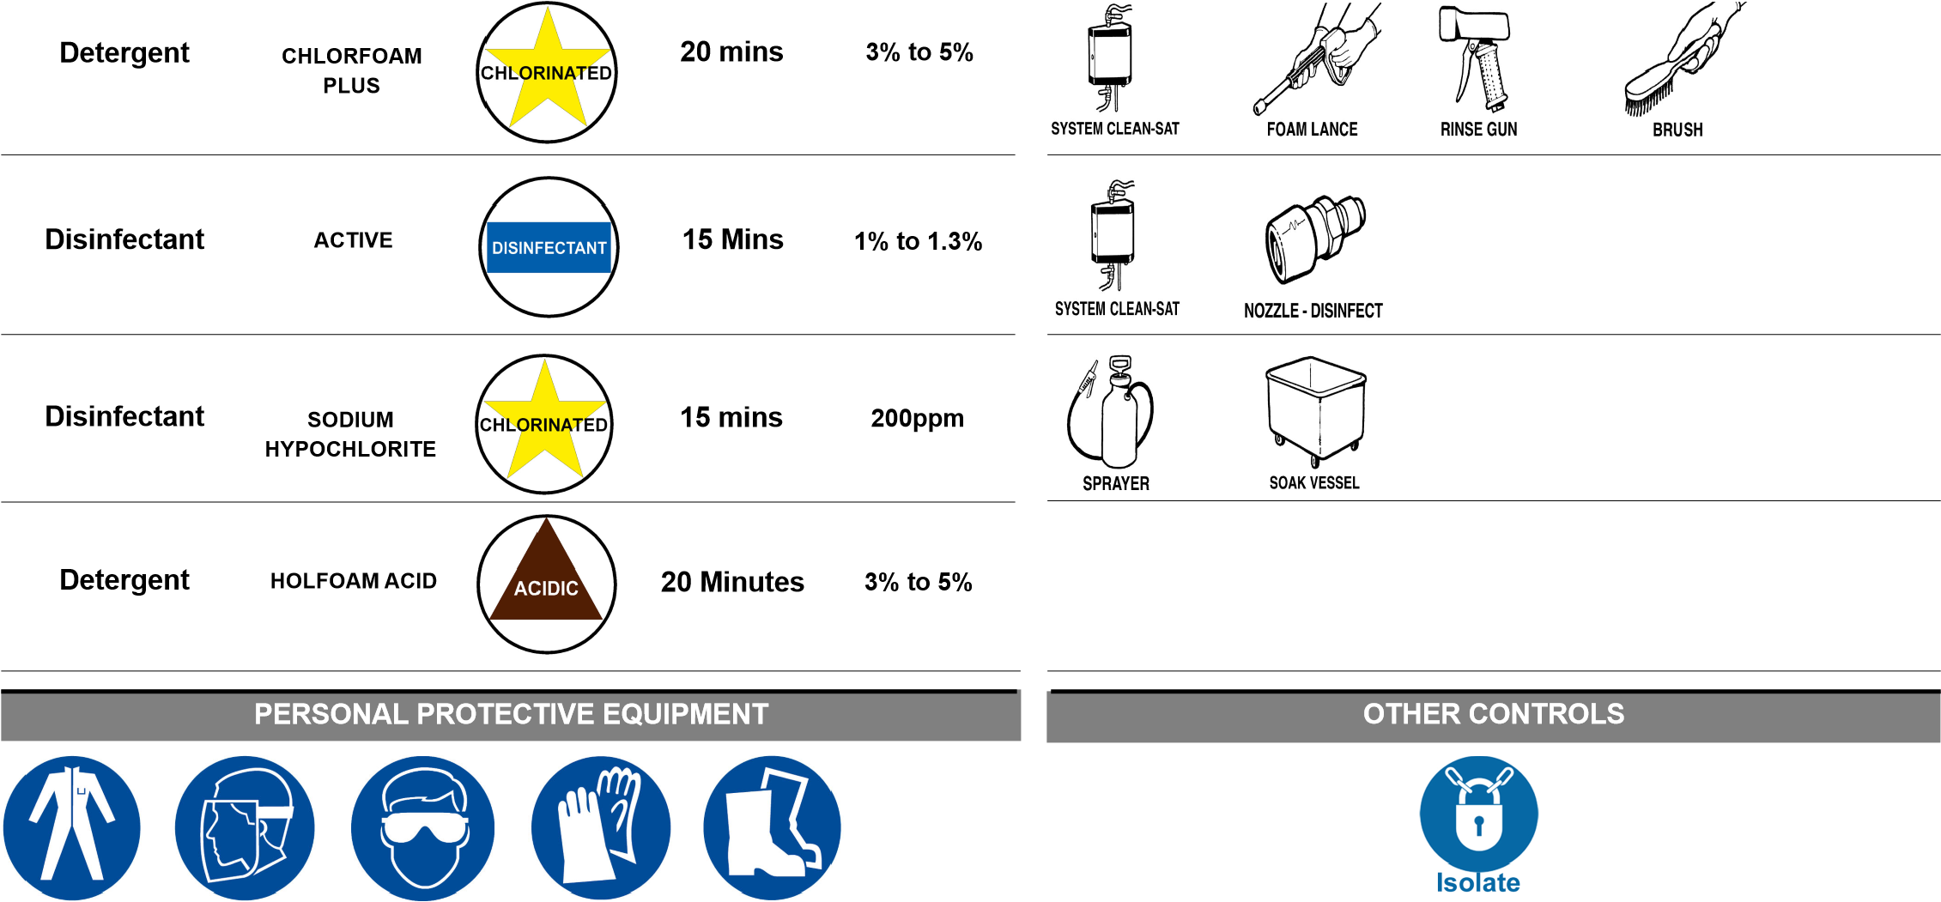

|  |  |
| --- | --- |
|  | **SPECIAL PRECAUTIONS** |
| 1. | **Chlorfoam Plus** to be replaced with **Holfoam Acid** on a weekly basis when instructed by the Hygiene Manager. |
|  | **DAILY CLEANING METHOD** |
| 1. | Switch off and isolate machine from power supply. |
| 2. | Dry wipe over control panels, plugs, sockets and other electrical components with **Protect Active Wipes,** then cover electrics to waterproof with clean polythene ensuring it is tied or made water resistant. |
| 3. | Remove any gross debris and place into grey/red colour coded tray for category 2 waste or tray marked category 2 floor waste tray and then into category 2 waste dolav. |
| 4. | Turn belt back on and whilst it is running rinse all surfaces using fresh clean water to remove any remaining debris . |
| 5. | Apply **Chlorfoam Plus** detergent foam solution to all surfaces ensuring even coverage. |
| 6. | Allow a minimum of 20 minutes contact time. |
| 7. | Switch off and isolate machine from power supply. |
| 8. | Whilst **Chlorfoam Plus** detergent solution is in contact, scrub any stubborn soiling using a designated blue scrubbing brush for the area. |
| 1. Pay particular attention to internal surfaces. 2. Rinse all surfaces thoroughly using fresh clean water. 3. Visually inspect to ensure all surfaces are clean and free from debris. 4. Reclean if necessary. 5. Spray disinfect all surfaces with **Active** solution. 6. Allow a minimum of 15 minutes contact time. 7. After clean the equipment remove the polythene. | |

**DAILY CLEANING METHOD**

16. Ensure document HYGBU/001 (Butchery Daily Hygiene Pre Op Sheet) is completed at end of shift.

# MONTHLY CLEANING METHOD

1. Switch off and isolate machine from power supply.
2. Dry wipe over control panels, plugs, sockets and other electrical components with **Protect Active Wipes**, then cover electrics to waterproof with clean polythene ensuring it is tied or made water resistant.
3. Engineers to remove metal covers at end of belts.
4. Hygiene rinse all surfaces using fresh clean water to remove any remaining debris.
5. Apply **Chlorfoam Plus** detergent foam solution to all surfaces ensuring even coverage.
6. Allow a minimum of 20 minutes contact time.
7. Whilst **Chlorfoam Plus** detergent solution is in contact, scrub any stubborn soiling using a designated blue scrubbing brush for the area.
8. Pay particular attention to internal surfaces.
9. Rinse all surfaces thoroughly using fresh clean water.
10. Visually inspect to ensure all surfaces are clean and free from debris.
11. Reclean if necessary.
12. Spray disinfect all surfaces with **Active** solution.
13. Allow a minimum of 15 minutes contact time.
14. Engineers to remove / open any motor and electrical covers to expose any hidden motors, control panels and water sensitive equipment.
15. Remove any gross debris and place into grey / colour coded tray for category 2 waste or tray marked category 2 floor waste tray and then into a category 2 waste dolav.
16. Hand clean any motors, chains, motor housing, covers and seals of the units carefully with **Protect Active Wipes**.
17. Visually inspect to ensure all surfaces are clean and free from debris.
18. Reclean if necessary.
19. Engineers to replace / close covers.
20. Cover panel / motor waterproof with clean polythene ensuring it is tied or made water resistant prior to cleaning equipment.
21. After clean the equipment remove the polythene.
22. Ensure document HYGBU/001 (Butchery Daily Hygiene Pre Op Sheet) is completed at end of shift.

**Photo No.**  1

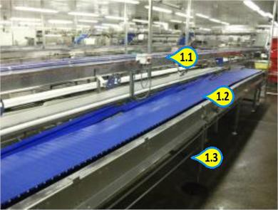**Key Inspection Points**

* 1. Conveyor Belts
  2. Conveyor Belts
  3. Undersides

**Photo No.**  2

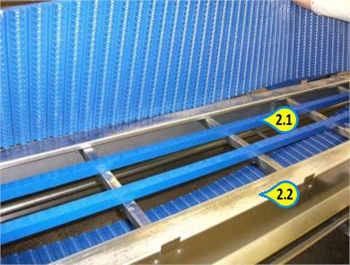**Key Inspection Points**

* 1. Belt Guides
  2. Framework

**Photo No.**  3

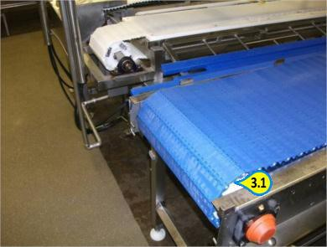**Key Inspection Points**

3.1 End Rollers

Area - Description

Responsibility For Cleaning

Engineering Assistance Req.

Responsibility For Inspection

Wholesale Butchery - Incline Conveyors

Hygiene Operative

Yes

Hygiene / Production Supervisor

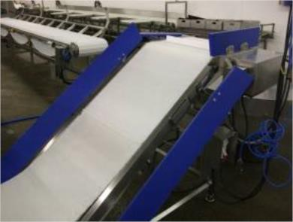

|  |  |  |
| --- | --- | --- |
| **USE PRODUCT COLOUR MINIMUM USE RATE**  **NAME CODE CONTACT** |  | **CLEANING TOOLS REQUIRED** |

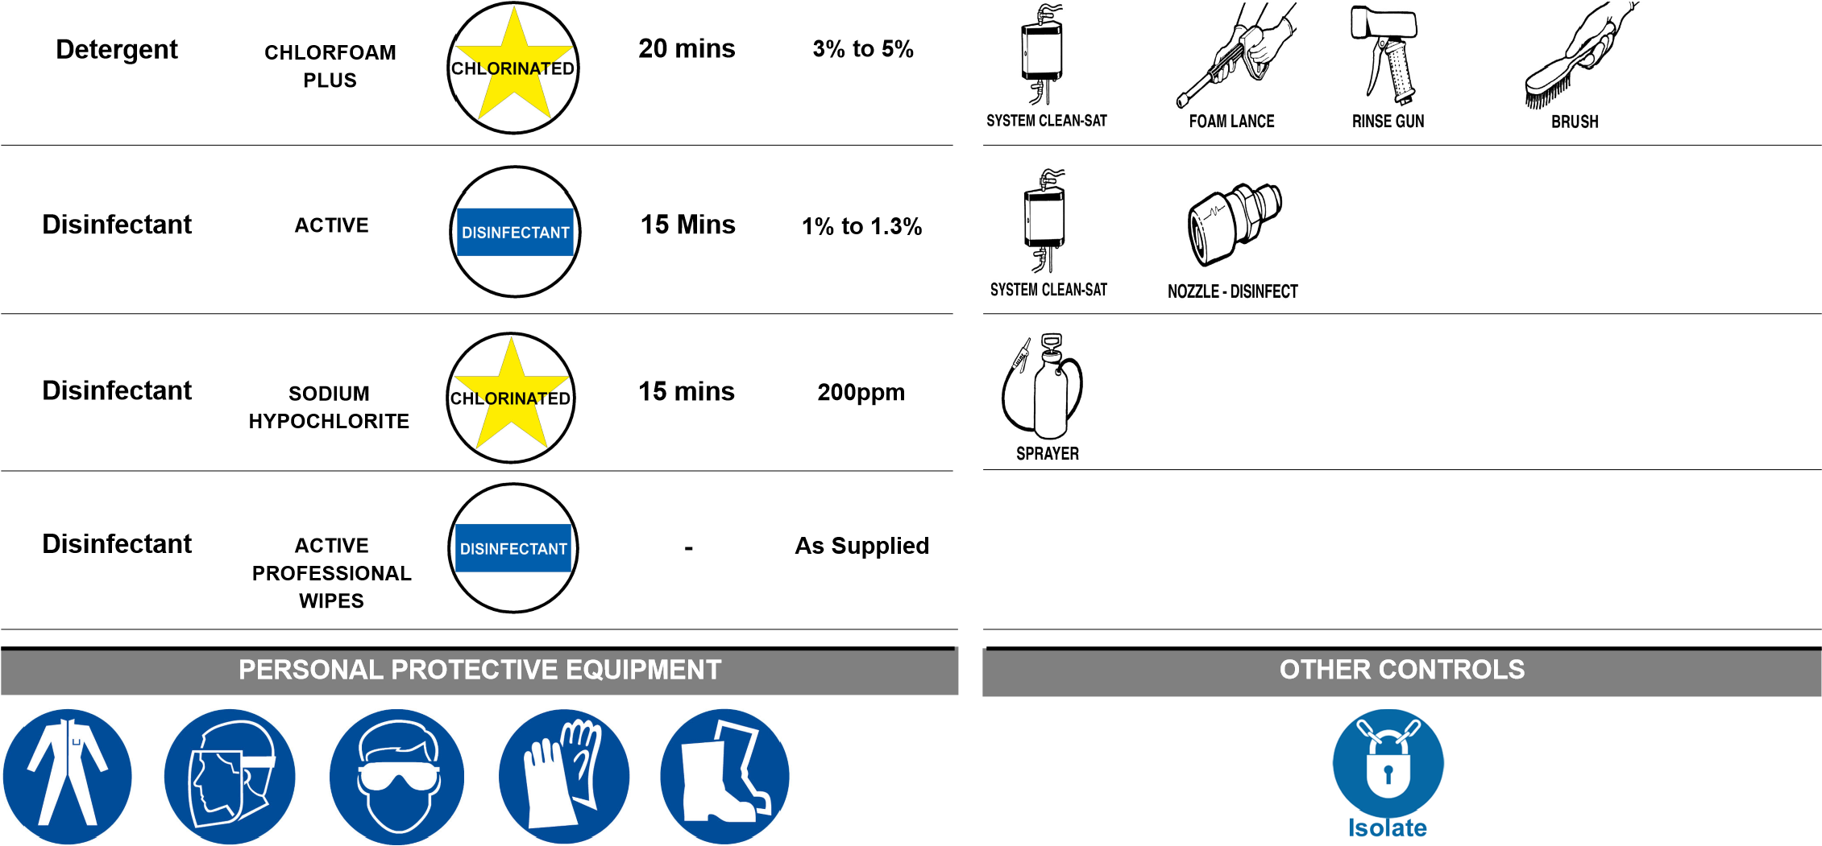

**SPECIAL PRECAUTIONS**

1. **Chlorfoam Plus** to be replaced with **Holfoam Acid** on a weekly basis when instructed by the Hygiene Manager.

# DAILY CLEANING METHOD

1. Switch off and isolate machine from power supply.
2. Dry wipe over control panels, plugs, sockets and other electrical components with **Protect Active Wipes** and then cover the electrics to waterproof with clean polythene ensuring it is tied or made water resistant.
3. Remove any gross debris and place into grey / red coded tray for category 2 waste or tray marked category 2 floor waste tray and then into category 2 waste dolav.
4. Lower guides.
5. Turn belt on and whilst it is running rinse all surfaces using fresh clean water to remove any remaining debris .
6. Apply **Chlorfoam Plus** detergent foam solution to all surfaces ensuring even coverage.
7. Allow a minimum of 20 minutes contact time.
8. Switch off and isolate machine from power supply.
9. Whilst **Chlorfoam Plus** detergent solution is in contact, scrub any stubborn soiling using designated blue scrubbing brush for area.
10. Pay particular attention to belt surfaces, rollers, guides, framework and undersides.
11. Turn belt on and whilst it is running rinse all surfaces thoroughly using fresh clean water.
12. Visually inspect to ensure all surfaces are clean and free from debris.
13. Reclean if necessary.
14. Spray disinfect all surfaces with **Active** solution.
15. Allow a minimum of 15 minutes contact time.

# DAILY CLEANING METHOD

1. Remove polythene covers from electrical components and re-wipe with **Protect Active Wipes**.
2. Ensure document HYGBU/001 Butchery Daily Hygiene Pre Op Sheet) is completed at end of shift.
3. Follow Daily Cleaning Procedure 1 to 13.
4. Spray belt surfaces with Sodium Hypochlorite disinfectant solution.
5. Allow a minimum 15 minutes contact time.
6. Rinse all surfaces thoroughly using fresh clean water.
7. Clean as Daily Procedure.

# MONTHLY CLEANING METHOD

1. Ensure document HYGBU/001 (Butchery Daily Hygiene Pre Op Sheet) is completed at end of shift.
2. Switch off and isolate machine from power supply.
3. Dry wipe over control panels, plugs, sockets and other electrical components with **Protect Active Wipes** and then cover the electrics to waterproof with clean polythene ensuring it is tied or made water resistant.
4. Engineers to remove / open any motor and electrical covers to expose any hidden motors, control panels and water sensitive equipment.
5. Remove any gross debris and place into grey / red coded tray for category 2 waste or tray marked category 2 floor waste tray and then into category 2 waste dolav.
6. Hand clean any motors, chains, motor housing, covers and seals of units carefully with **Protect Active Wipes.**
7. Visually inspect to ensure all surfaces are clean and free from debris.
8. Reclean if necessary.
9. Engineers to replace/close covers.
10. Cover panel / motor waterproof with clean polythene ensuring it is tied or made water resistant prior to cleaning equipment.
11. After cleaning remove polythene.
12. Ensure document HYGBU/001 Butchery Daily Hygiene Pre Op Sheet) is completed at end of shift.

**Photo No.**  1

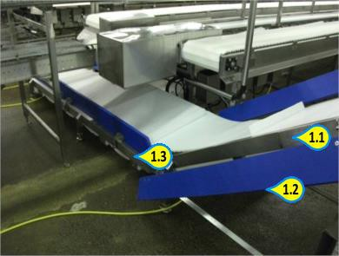**Key Inspection Points**

* 1. Framework
  2. Undersides
  3. Undersides

**Photo No.**  2

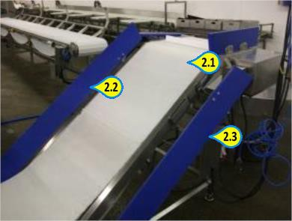**Key Inspection Points**

* 1. Conveyor
  2. Guides
  3. Guides

B04/0

**WHIZZARDS**

Page 1 of 2

Area - Description

Responsibility For Cleaning

Engineering Assistance Req.

Responsibility For Inspection

Wholesale Butchery - Whizzards

Hygiene / Production Operative

No

Hygiene / Production Supervisor

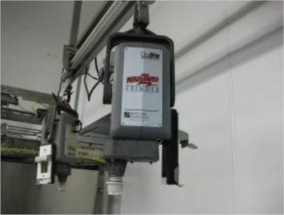

|  |  |  |
| --- | --- | --- |
| **USE PRODUCT COLOUR MINIMUM USE RATE**  **NAME CODE CONTACT** |  | **CLEANING TOOLS REQUIRED** |



**CHLORFOAM**

**PLUS**

**Detergent**

**% -5%**

**3**



**mins**

**20**



**Disinfectant**

**ACTIVE**



**1**

**% to 1.3%**



**15**

**Mins**



**Disinfectant**

**ACTIVE**

**PROFESSIONAL**

**WIPES**



**As Supplied**



**-**



**OTHER CONTROLS**

**PERSONAL PROTECTIVE EQUIPMENT**



# SPECIAL PRECAUTIONS

1. All sharp blades are to be removed by Production or Engineering Operatives.
2. **BE AWARE OF VERY SHARP BLADES WHEN CLEANING.**

# DAILY CLEANING METHOD

**Production Clean:**

1. Switch off and isolate the machine from the power supply.
2. Remove blade and cable. Rinse blade and cable to remove any gross debris.
3. Visually inspect to ensure all surfaces are clean and free from debris.
4. The blades are then sharpened by the production staff and then passed to hygiene for Daily Cleaning Procedure.

**Hygiene Clean:**

1. Switch off and isolate machine from the power supply.
2. Hand clean overhead mount with motor with **Protect Active Wipes** and visually inspect for cleanliness.
3. Rinse all removed blades and cables thoroughly using fresh clean water.
4. Use the wash down system and apply **Chlorfoam Plus** detergent to blades and cables.
5. Use a detail brush to remove any stubborn debris. Allow 20 minutes contact time. Rinse away all detergent. Visually inspect to ensure all surfaces are clean and free from debris. Reclean if necessary.
6. Spray disinfect all surfaces using Active solution and hang up ready for production to re-assemble. Allow a minimum of 15 minutes contact time.
7. Ensure document HYGBU/001 (Butchery Daily Hygiene Pre Op Sheet) is completed at end of shift.

|  |
| --- |
| Cleaning Instruction Card © |
| **WHIZZARDS** |

B04/0

Page 2 of 2

**Photo No.**  1

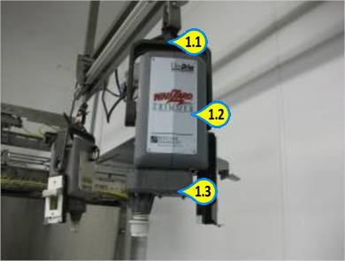**Key Inspection Points**

* 1. Overhead Mount
  2. Motor
  3. Undersides

**Photo No.**  2

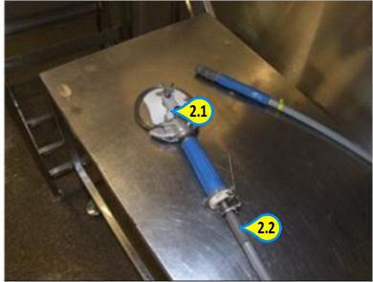**Key Inspection Points**

* 1. Blades
  2. Cables

Area - Description

Responsibility For Cleaning

Engineering Assistance Req.

Responsibility For Inspection

Wholesale Butchery - Grasselli Autofeed Derinder

Hygiene Operative

Yes

Hygiene Supervisor

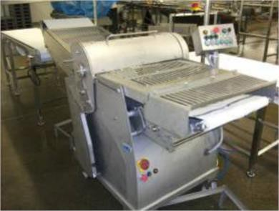

|  |  |  |
| --- | --- | --- |
| **USE PRODUCT COLOUR MINIMUM USE RATE**  **NAME CODE CONTACT** |  | **CLEANING TOOLS REQUIRED** |

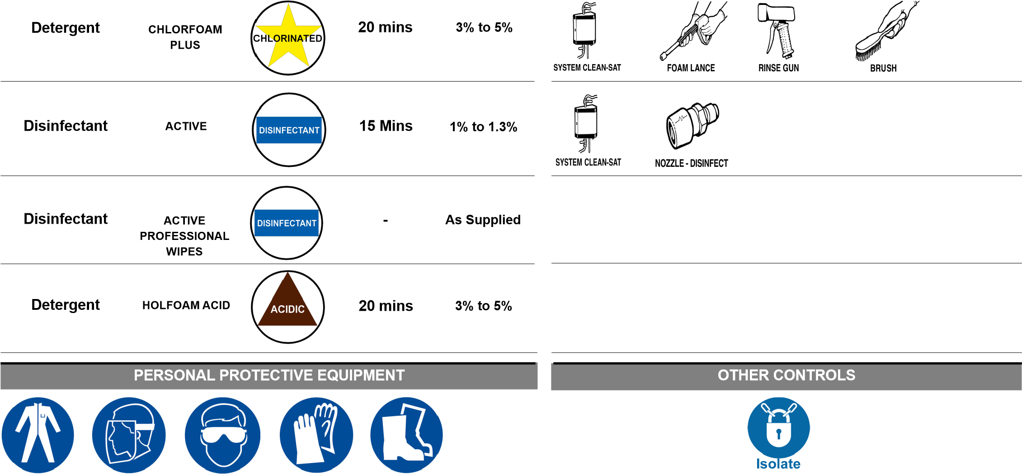

|  |  |
| --- | --- |
|  | **SPECIAL PRECAUTIONS** |
| 1. | Blades to be removed by Production or Engineering Operatives. |
| 2. | when Production, Hygiene or engineering remove nuts and bolts or any other small items then they must be placed into designated container so the small parts do not become lost. |
| 3. | **Chlorfoam Plus** to be replace with **Holfoam Acid** on a weekly basis when instructed by Hygiene Manager. |
|  | **DAILY CLEANING METHOD** |
| 1. | Switch off and isolate the machine from the power supply. |
| 2. | Remove any gross debris and place in a grey / red colour coded tray for category 2 waste or a tray marked category 2 floor waste tray and then into a category 2 waste dolav. |
| 3. | Production to carry out full strip down. |
| 4. | Production to lift main cover and remove roller, blade and stripper assembly. |
| 5. | Remove any gross debris and place in a suitable waste container. |
| 6. | Rinse all surfaces using fresh clean water to remove any remaining debris. |
| 7. | Apply **Chlorfoam Plus** detergent foam solution to all surfaces ensuring an even coverage. |
| 8. | Allow a minimum of 20 minutes contact time. |
| 1. Whilst **Chlorfoam Plus** detergent solution is in contact, scrub any stubborn soiling using a designated blue scrubbing brush for the area. 2. Pay particular attention to conveyors, rollers, end rollers, blades, stripper assembly, gripper, framework and undersides. 3. Rinse all surfaces thoroughly using fresh clean water. 4. Visually inspect to ensure all surfaces are clean and free from debris. 5. Reclean if necessary. 6. Spray disinfect all surfaces using **Active** solution. | |

# DAILY CLEANING METHOD

1. Allow a minimum 15 minutes contact time.
2. Remove polythene covers from electrical components and re-wipe with **Protect Active Wipes.**
3. Ensure document HYGBU/001 (Butchery Daily Hygiene Pre Op Sheet) is completed at the end of the shift.
4. Production to reassemble.

# MONTHLY CLEANING METHOD

1. Switch off and isolate machine from power supply.
2. Dry wipe over control panels, plugs, sockets and other electrical components with **Protect Active Wipes** and then cover the electrics to waterproof with clean polythene ensuring it is tied or made water resistant.
3. Engineers to remove / open any motor and electrical covers to expose any hidden motors, control panels and water sensitive equipment.
4. Remove any gross debris and place into grey / red colour coded tray for category 2 waste or tray marked category 2 floor waste tray and then into a category 2 waste dolav.
5. Hand clean any motors, chains, motor housing, rear surfaces, covers and seals of the units carefully with **Protect Active Wipes**.
6. Visually inspect to ensure all surfaces are clean and free from debris.
7. Reclean if necessary.
8. Engineers to replace / close covers.
9. Cover panel / motor waterproof with clean polythene, ensuring it is tied or made water resistant prior to cleaning equipment.
10. After cleaning equipment remove polythene.
11. Ensure document HYGBU/001 (Butchery Daily Hygiene Pre Op Sheet) is completed at end of shift.

1

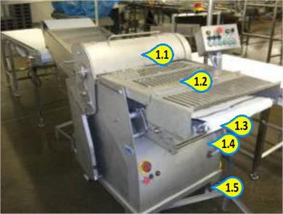**Key Inspection Points**

* 1. Covers
  2. Covers
  3. Rollers
  4. Framework
  5. Undersides

**Photo No.**  2

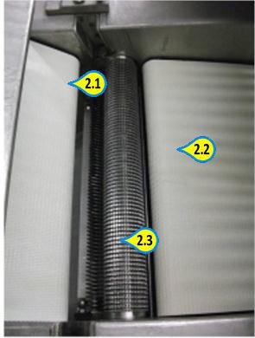**Key Inspection Points**

* 1. Conveyor Belts
  2. Conveyor Belts
  3. Roller and Grabber

**Photo No.**  3

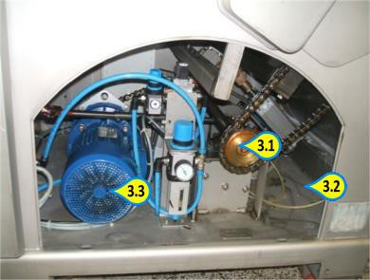**Key Inspection Points**

* 1. Chain and Drive
  2. Internal Surfaces
  3. Motor and Motor Housing

4

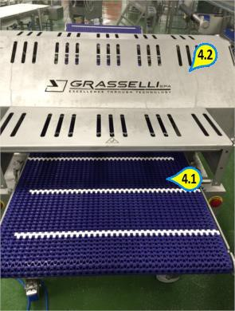**Key Inspection Points**

* 1. Infeed belt
  2. Framework and external surfaces

**Photo No.**  5

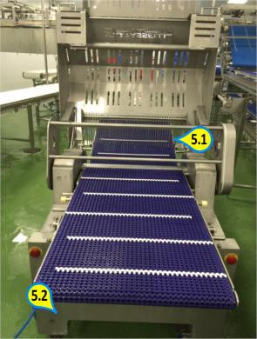**Key Inspection Points**

* 1. Internal surfaces
  2. Framework

6

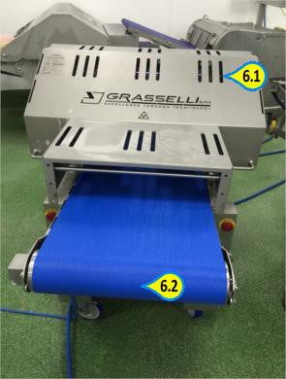**Key Inspection Points**

* 1. External surfaces
  2. Infeed belt

**Photo No.**  7

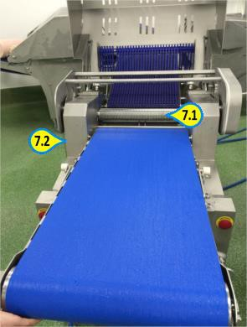**Key Inspection Points**

* 1. Intenal surfaces
  2. Framework

Area - Description

Responsibility For Cleaning

Engineering Assistance Req.

Responsibility For Inspection

Wholesale Butchery - Band Saw

Hygiene Operative

Yes

Hygiene Supervisor

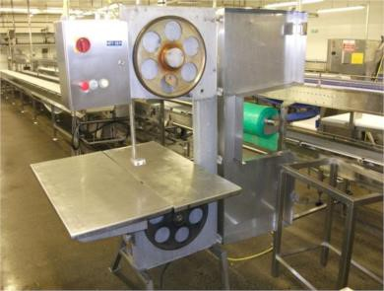

|  |  |  |
| --- | --- | --- |
| **USE PRODUCT COLOUR MINIMUM USE RATE**  **NAME CODE CONTACT** |  | **CLEANING TOOLS REQUIRED** |



# SPECIAL PRECAUTIONS

1. **All sharp blades are to be removed by Production or Engineering Operatives.**
2. **Chlorfoam Plus** to be replaced with **Holfoam Acid** on a weekly basis when instructed by the Hygiene Manager.

# DAILY CLEANING METHOD

1. Switch off and isolate the machine from the power supply.
2. Dry wipe over control panels, plugs, sockets and other electrical components with **Protect Active Wipes** and then cover the electrics to waterproof with clean polythene, ensuring it is tied or made water resistant.
3. Production to empty catch tray in a grey / red colour coded tray for category 2 waste or a tray marked category 2 floor waste tray and then into a category 2 waste dolav.
4. Production to open covers, remove blade and remove white nylon blade guide.
5. Remove any gross debris and place in a grey / red colour coded tray for category 2 waste or a tray marked category 2 floor waste tray and then into a category 2 waste dolav.
6. Rinse all surfaces using fresh clean water to remove any remaining debris.
7. Apply **Chlorfoam Plus** detergent foam solution to all surfaces ensuring an even coverage.
8. Allow a minimum of 20 minutes contact time.
9. Whilst **Chlorfoam Plus** detergent solution is in contact, scrub any stubborn soiling using a designated blue scrubbing brush for the area.
10. Pay particular attention to blade wheels, covers, bed, catch tray, framework and undersides.
11. Rinse all surfaces thoroughly using fresh clean water.
12. Visually inspect to ensure all surfaces are clean and free from debris.
13. Reclean if necessary.
14. Spray disinfect all surfaces using **Active** solution.

# DAILY CLEANING METHOD

1. Allow a minimum 15 minutes contact time.
2. Remove polythene covers from electrical components and re-wipe with **Protect Active Wipes**.
3. Ensure document HYGBU/001 (Butchery Daily Hygiene Pre Op Sheet) is completed at the end of the shift.
4. Production to reassemble.

# MONTHLY CLEANING METHOD

1. Switch off and isolate machine from power supply.
2. Dry wipe over control panels, plugs, sockets and other electrical components with **Protect Active Wipes** and then cover electrics to waterproof with clean polythene ensuring it is tied or made water resistant.
3. Engineers to remove / open any motor and electrical covers to expose any hidden motors, control panels and water sensitive equipment.
4. Remove any gross debris and place into grey / red colour coded tray for category 2 waste or a tray marked category 2 floor waste tray then into a category 2 waste dolav.
5. Hand clean any motors, chains motor housing, covers and seals of units carefully with **Protect Active Wipes**.
6. Visually inspect to ensure all surfaces are clean and free from debris.
7. Reclean if necessary.
8. Engineers to replace / close covers.
9. Cover panel / motor waterproof with clean polythene ensuring it is tied or made water resistant prior to cleaning equipment.
10. After cleaning equipment remove polythene.
11. Ensure document HYGBU/001 (Butchery Daily Hygiene Pre Op Sheet) is completed at end of shift.

**Photo No.**  1

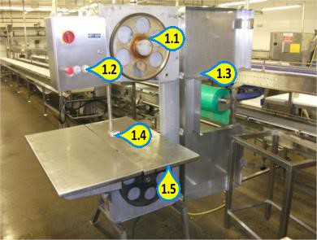**Key Inspection Points**

* 1. Blade Wheel
  2. Controls
  3. Cover & Framework
  4. Guide
  5. Bed & Undersides

**Photo No.**  2

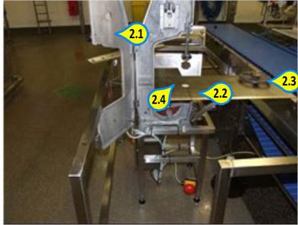**Key Inspection Points**

* 1. Cover
  2. Bed
  3. Blade Wheel Removed
  4. Guide

**Photo No.**  3

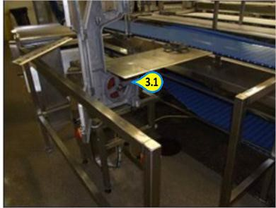**Key Inspection Points**

3.1 Framework, Legs & Undersides

4

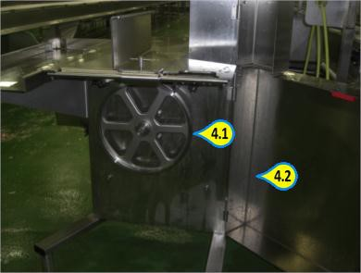**Key Inspection Points**

* 1. Blade Wheel
  2. Internal Areas

**Photo No.**  5

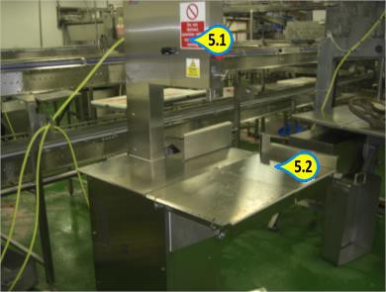**Key Inspection Points**

* 1. Control Panel
  2. Bed

**Photo No.**  6

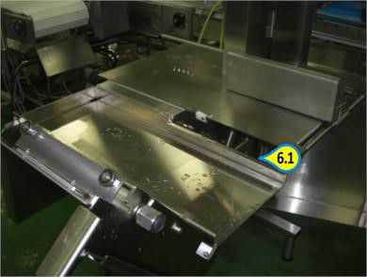**Key Inspection Points**

6.1 Bed opens upward - internal surfaces

B07/0

# DERINDER BLADE AND ROLLER RACK Page 1 of 2

Wholesale Butchery - Derinder Blade and Roller Rack

Hygiene Operative

No

Hygiene Supervisor

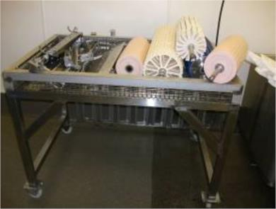

|  |  |  |
| --- | --- | --- |
| **USE PRODUCT COLOUR MINIMUM USE RATE**  **NAME CODE CONTACT** |  | **CLEANING TOOLS REQUIRED** |



**CHLORFOAM**

**PLUS**

**Detergent**

**% to 5%**

**3**



**mins**

**20**



**Disinfectant**

**ACTIVE**



**1**

**% to 1.3%**



**15**

**Mins**



**Detergent**

**HOLFOAM ACID**



**3**

**% to 5%**



**20**

**mins**



**OTHER CONTROLS**

**PERSONAL PROTECTIVE EQUIPMENT**



## SPECIAL PRECAUTIONS

1. **Be aware of sharp blades on racking.**
2. Chlorfoam Plus to be replaced with Holfoam Acid on a weekly basis when instructed by the Hygiene Manager.

## DAILY CLEANING METHOD

1. Remove blades and rollers from racking and do not place on the floor.
2. Remove any gross debris and place in a grey / red colour coded tray for category 2 waste or a tray marked category 2

floor waste tray and then into a category 2 waste dolav.

1. Rinse all surfaces using fresh clean water to remove any remaining debris.
2. Apply **Chlorfoam Plus** detergent foam solution to all surfaces ensuring an even coverage.
3. Allow a minimum of 20 minutes contact time.
4. Whilst **Chlorfoam Plus** detergent solution is in contact, scrub any stubborn soiling using a designated blue scrubbing brush for the area.
5. Pay particular attention to wheels, framework and undersides.
6. Rinse all surfaces thoroughly using fresh clean water.
7. Visually inspect to ensure all surfaces are clean and free from debris.
8. Reclean if necessary.
9. Spray disinfect all surfaces using **Active** solution.
10. Allow a minimum 15 minutes contact time.
11. Ensure document HYGBU/001 (Butchery Daily Hygiene Pre Op Sheet) is completed at the end of the shift.
12. Replace blades and rollers.

## KEY INSPECTION POINTS

|  |
| --- |
| Cleaning Instruction Card © |
| **DERINDER BLADE AND ROLLER RACK** |

B07/0

Page 2 of 2

1

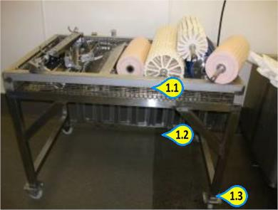**Key Inspection Points**

1.1 Framework

1.2 Undersides

1.3 Wheels

B08/0

**ROLLER CONVEYOR**

Page 1 of 2

Wholesale Butchery - Roller Conveyor

Hygiene Operative

No

Hygiene Supervisor

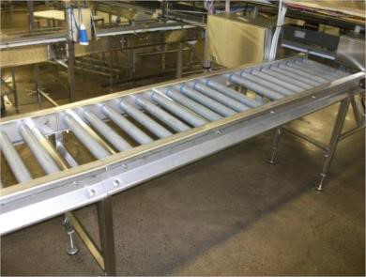

|  |  |  |
| --- | --- | --- |
| **USE PRODUCT COLOUR MINIMUM USE RATE**  **NAME CODE CONTACT** |  | **CLEANING TOOLS REQUIRED** |



**CHLORFOAM**

**PLUS**

**Detergent**

**% to 5%**

**3**



**mins**

**20**



**Disinfectant**

**ACTIVE**



**1**

**% to 1.3%**



**15**

**Mins**



**Detergent**

**HOLFOAM ACID**



**3**

**% to 5%**



**20**

**mins**



**OTHER CONTROLS**

**PERSONAL PROTECTIVE EQUIPMENT**



**SPECIAL PRECAUTIONS**

1. **Chlorfoam Plus** to be replaced with **Holfoam Acid** on a weekly basis when instructed by the Hygiene Manager.

## DAILY CLEANING METHOD

1. Remove any gross debris and place in a grey / red colour coded tray for category 2 waste or a tray marked category 2 floor waste tray and then into a category 2 waste dolav.
2. Rinse all surfaces using fresh clean water to remove any remaining debris.
3. Apply **Chlorfoam Plus** detergent foam solution to all surfaces ensuring an even coverage.
4. Allow a minimum of 20 minutes contact time.
5. Whilst **Chlorfoam Plus** detergent solution is in contact, scrub any stubborn soiling using a designated blue scrubbing brush for the area.
6. Pay particular attention to both sides of rollers, undersides and framework.
7. Rinse all surfaces thoroughly using fresh clean water.
8. Visually inspect to ensure all surfaces are clean and free from debris.
9. Reclean if necessary.
10. Spray disinfect all surfaces using **Active** solution.
11. Allow a minimum 15 minutes contact time.
12. Ensure document HYGBU/001 (Butchery Daily Hygiene Pre Op Sheet) is completed at the end of the shift.

|  |
| --- |
| Cleaning Instruction Card © |
| **ROLLER CONVEYOR** |

B08/0

Page 2 of 2

1

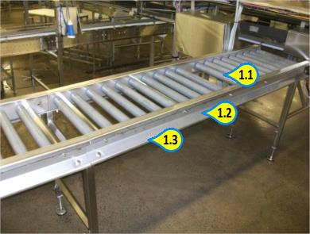**Key Inspection Points**

* 1. Rollers
  2. Framework
  3. Undersides

Wholesale Butchery - Open Top Grasselli Derinder x 5

Hygiene Operative

Yes

Hygiene Operative

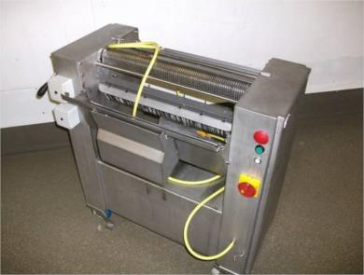

|  |  |  |
| --- | --- | --- |
| **USE PRODUCT COLOUR MINIMUM USE RATE**  **NAME CODE CONTACT** |  | **CLEANING TOOLS REQUIRED** |



|  |  |
| --- | --- |
|  | **SPECIAL PRECAUTIONS** |
| 1. | Blades to be removed by Production or Engineering Operatives. |
| 2. | When Production, Hygiene, or Engineering remove nuts and Bolts or any other small items then they must be placed in the designated container so the small parts do not become lost. |
| 3. | **Chlorfoam Plus** to be replaced with **Holfoam Acid** on a weekly basis when instructed by the Hygiene Manager. |
|  | **DAILY CLEANING METHOD** |
| 1. | Switch off and isolate the machine from the power supply. |
| 2. | Remove any gross debris and place in a grey / red colour coded tray for category 2 waste or a tray marked category 2 floor waste tray and then into a category 2 waste dolav. |
| 3. | Production to carry out full strip down. |
| 4. | Production to lift main cover and remove blade and stripper assembly. |
| 5. | Remove any gross debris and place in a suitable waste container. |
| 6. | Rinse all surfaces using fresh clean water to remove any remaining debris. |
| 7. | Apply **Chlorfoam Plus** detergent foam solution to all surfaces ensuring an even coverage. |
| 8. | Allow a minimum of 20 minutes contact time. |
| 1. Whilst **Chlorfoam Plus** detergent solution is in contact, scrub any stubborn soiling using a designated blue scrubbing brush for the area. 2. Pay particular attention to blades, stripper assembly, gripper, framework and undersides. 3. Rinse all surfaces thoroughly using fresh clean water. 4. Visually inspect to ensure all surfaces are clean and free from debris. 5. Reclean if necessary. 6. Spray disinfect all surfaces using **Active** solution. | |

## DAILY CLEANING METHOD

1. Allow a minimum 15 minutes contact time.
2. Remove polythene covers from electrical components and re-wipe with **Protect Active Wipes**.
3. Ensure document HYGBU/001 (Butchery Daily Hygiene Pre Op Sheet) is completed at the end of the shift.
4. Production to reassemble.

## MONTHLY CLEANING METHOD

1. Switch off and isolate the machine from the power supply.
2. Dry wipe over control panels, plugs, sockets and other electrical components with **Protect Active Wipes** and then cover electrics to waterproof with clean polythene ensuring it is tied or made water resistant.
3. Engineers to remove / open any motor and electrical covers to expose any hidden motors, control panels and water sensitive equipment.
4. Remove any gross debris and place into grey / red colour coded tray for category 2 waste or a tray marked category 2 floor waste tray and then into a category 2 waste dolav.
5. Hand clean any motors, chains, motor housing, covers and seals of the units using **Protect Active Wipes**.
6. Visually inspect to ensure all surfaces are clean and free from debris.
7. Reclean if necessary.
8. Engineers to replace / close covers.
9. Cover panel, motor waterproof with clean polythene, ensuring it is tied or made water water resistant prior to cleaning equipment.
10. After cleaning equipment remove polythene.
11. Ensure document HYGBU/001 (Butchery Daily Hygiene Pre Op Sheet) is completed at the end of the shift.

**Photo No.**  1

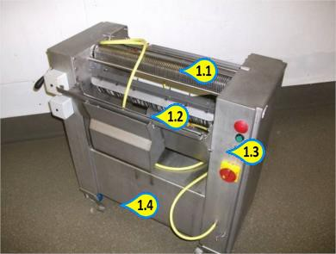**Key Inspection Points**

* 1. Blades & Gripper
  2. Stripper Assembly
  3. Framework
  4. Undersides

**Photo No.**  2

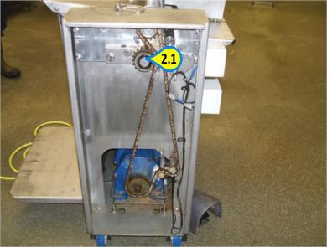**Key Inspection Points**

2.1 Chains & Drives

**Photo No.**  3

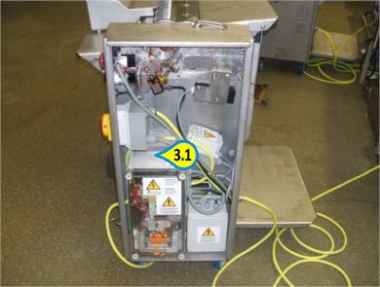**Key Inspection Points**

3.1 Motor Housing

Area - Description

Responsibility For Cleaning

Engineering Assistance Req.

Responsibility For Inspection

Wholesale Butchery - Single Lane Interlux Conveyor

Hygiene Operative

Yes

Hygiene Supervisor

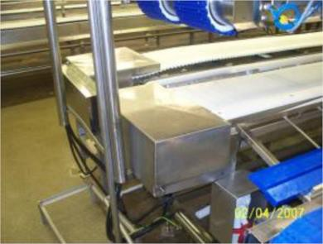

|  |  |  |
| --- | --- | --- |
| **USE PRODUCT COLOUR MINIMUM USE RATE**  **NAME CODE CONTACT** |  | **CLEANING TOOLS REQUIRED** |

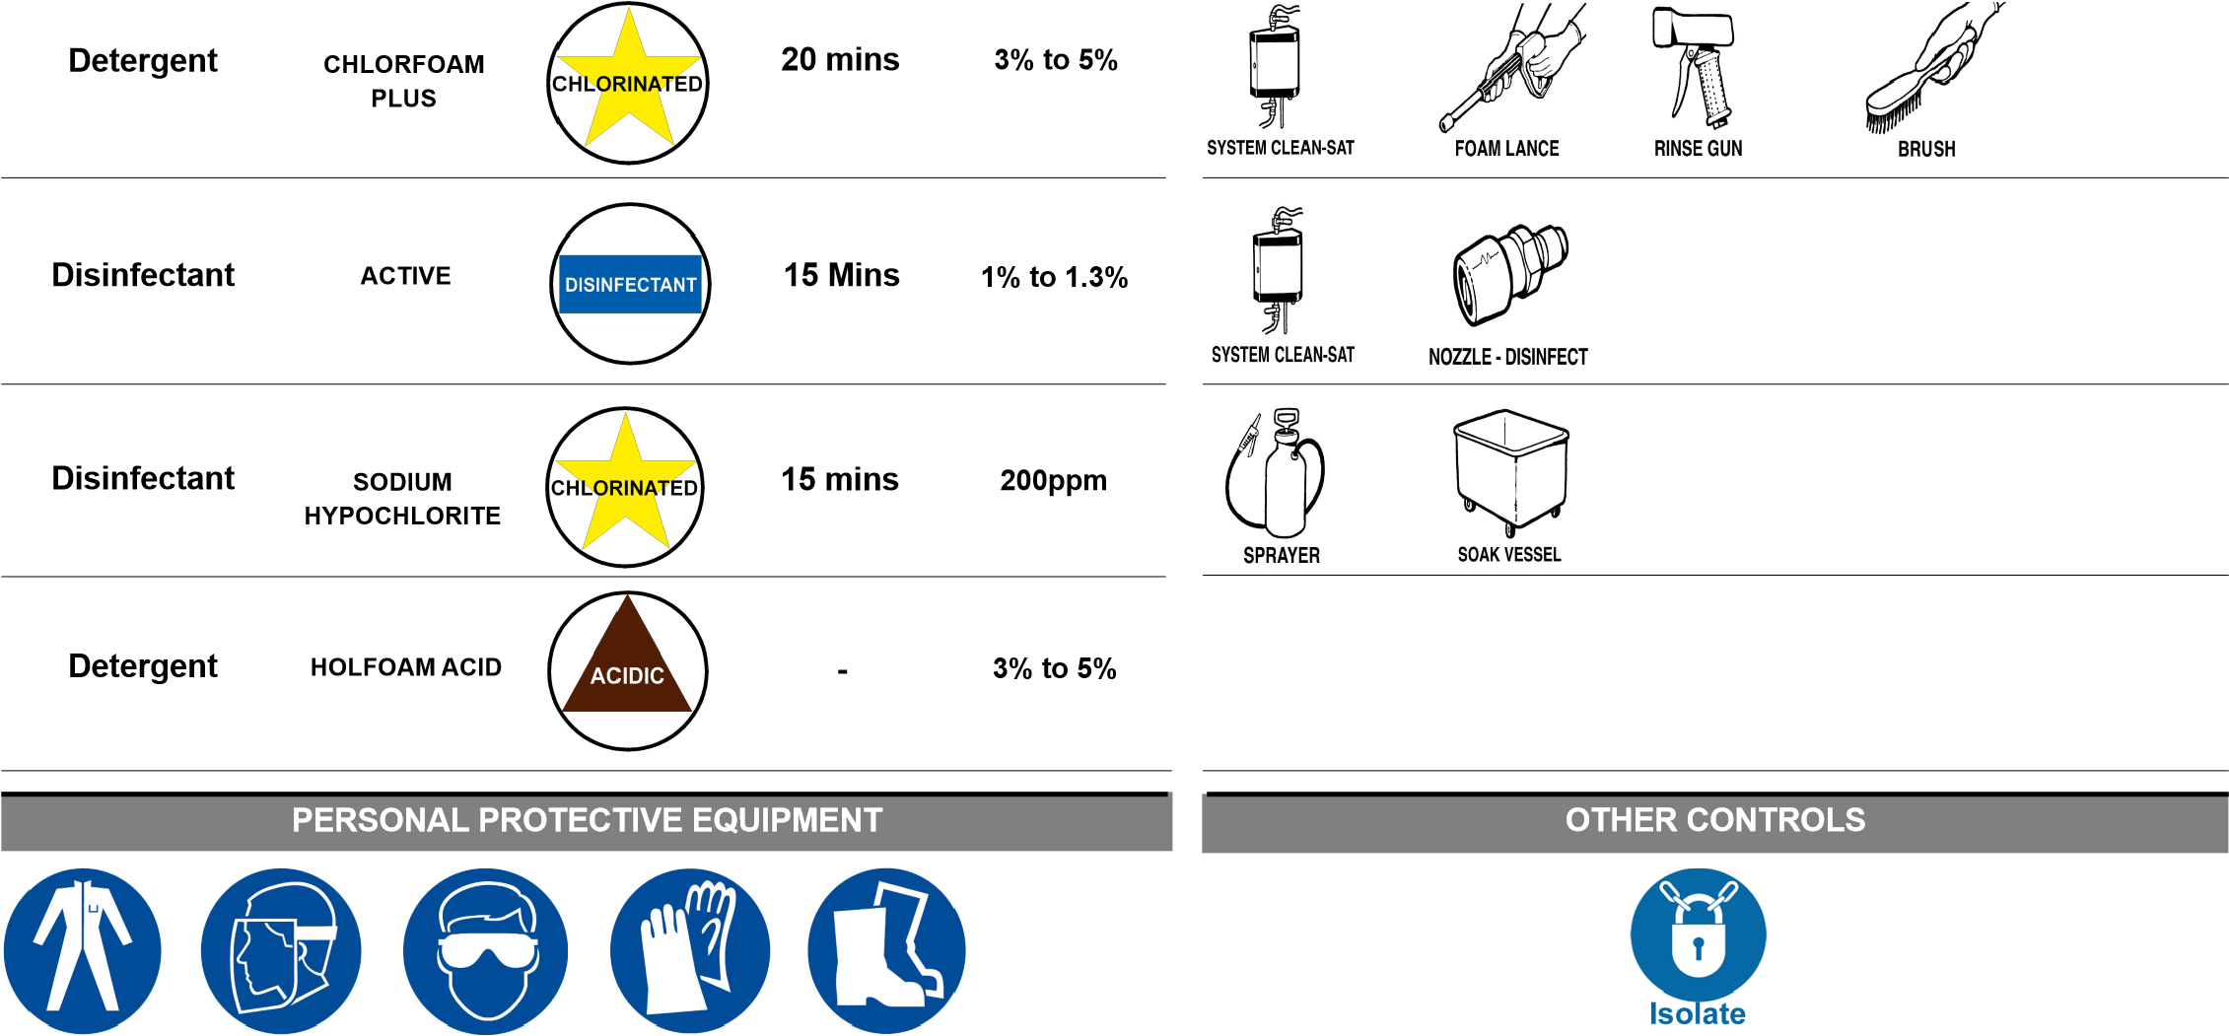

**SPECIAL PRECAUTIONS**

1. **Chlorfoam Plus** to be replaced with **Holfoam Acid** on a weekly basis when instructed by the Hygiene Manager.

## DAILY CLEANING METHOD

1. Switch off and isolate machine from power supply.
2. Dry wipe over control panels, plugs, sockets and other electrical components with **Protect Active Wipes** and then cover the electrics to waterproof with clean polythene ensuring it is tied or made water resistant.
3. Remove any gross debris and place into grey / red colour code tray for category 2 waste or a tray marked category 2 floor waste tray and then into a category 2 was dolav.
4. Turn belt on and whilst it is running rinse all surfaces using fresh clean water to remove any remaining debris .
5. Apply **Chlorfoam Plus** detergent foam solution to all surfaces ensuring even coverage.
6. Allow minimum of 20 minutes contact time.
7. Switch off and isolate machine from power supply.
8. Whilst **Chlorfoam Plus** detergent solution is in contact, scrub any stubborn soiling using a designated blue scrubbing brush for the area.
9. Pay particular attention to belt surfaces, rollers, strips, guides, framework and undersides.
10. Turn belt on and whilst it is running rinse all surfaces thoroughly using fresh clean water.
11. Visually inspect to ensure all surfaces are clean and free from debris.
12. Reclean if necessary.
13. Spray disinfect all surfaces with **Active** solution.
14. Allow a minimum of 15 minutes contact time.
15. Remove polythene covers from electrical components and re-wipe with **Protect Active Wipes**.

**DAILY CLEANING METHOD**

1. Ensure document HYGBU/001 (Butchery Daily Hygiene Pre Op Sheet) is completed at the end of the shift.

## MONTHLY CLEANING METHOD

1. Switch off and isolate machine from power supply.
2. Dry wipe over control panels, plugs, sockets and other electrical components with **Protect Active Wipes** and then cover the electrics to waterproof with clean polythene ensuring it is tied or made water resistant.
3. Engineers to remove / open any motor and electrical covers to expose any hidden motors, control panels and water sensitive equipment.
4. Remove any gross debris and place into grey / red colour code tray for category 2 waste or a tray marked category 2 floor waste tray and then into a category 2 was dolav.
5. Hand clean any motors, chains, motor housing, covers and seals of units carefully with **Protect Active Wipes**.
6. Visually inspect to ensure all surfaces are clean and free from debris.
7. Reclean if necessary.
8. Engineers to replace / close covers.
9. Cover panel / motor waterproof with clean polythene ensuring it is tied or made water resistant prior to cleaning equipment.
10. After cleaning equipment remove polythene.
11. Ensure document HYGBU/001 (Butchery Daily Hygiene Pre Op Sheet) is completed at the end of the shift.

**Photo No.**  1

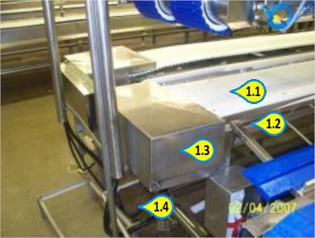**Key Inspection Points**

* 1. Conveyor Belt
  2. Framework
  3. End Cover
  4. Undersides

**Photo No.**  2

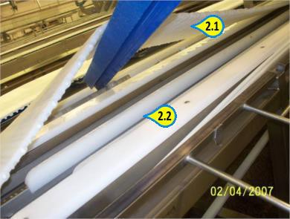**Key Inspection Points**

* 1. Undersides of Belt
  2. Strips

**Photo No.**  3

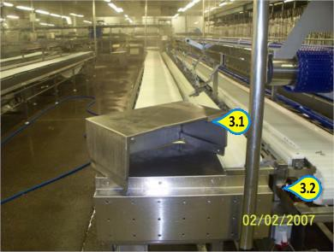**Key Inspection Points**

* 1. End Cover Removed
  2. Surfaces Under Cover Exposed

Area - Description

Responsibility For Cleaning

Engineering Assistance Req.

Responsibility For Inspection

Wholesale Butchery - Knife Washing Machine

Hygiene Operative

Yes

Hygiene Supervisor

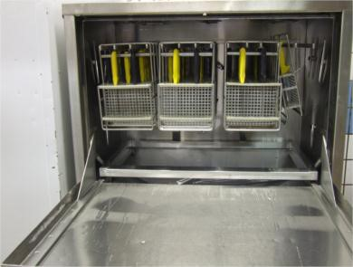

|  |  |  |
| --- | --- | --- |
| **USE PRODUCT COLOUR MINIMUM USE RATE**  **NAME CODE CONTACT** |  | **CLEANING TOOLS REQUIRED** |

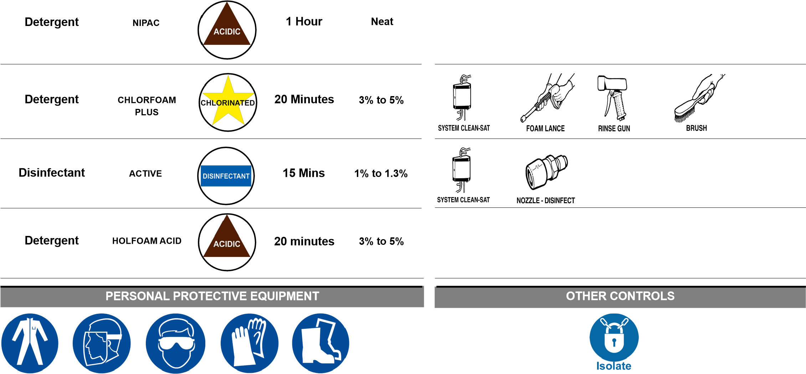

**SPECIAL PRECAUTIONS**

1. **Chlorfoam Plus** to be replaced with **Holfoam Ac**id on a weekly basis when instructed by the Hygiene Manager.

## DAILY CLEANING METHOD

1. Switch off and isolate the machine from power supply.
2. Dry wipe over control panels, plugs, sockets and other electrical components with **Protect Active Wipes** and then cover electrics to waterproof with clean polythene, ensuring it is tied or made water resistant.
3. Remove contents of machine and filter tray.
4. Open drain valve to empty tank.
5. Remove any gross debris and place into grey / red colour coded tray for category 2 waste or tray marked category 2 floor waste tray and then into a category 2 waste dolav.
6. Rinse all surfaces using fresh clean water to remove any remaining debris.
7. Apply **Chlorfoam Plus** detergent foam solution to all surfaces ensuring even coverage.
8. Allow minimum of 20 minutes contact time.
9. Whilst **Chlorfoam Plus** detergent solution is in contact, scrub any stubborn soiling using designated white scrubbing brush for the area.
10. Pay particular attention to internal surfaces, nozzles, filters, tank, framework and undersides.
11. Rinse all surfaces using fresh clean water.
12. Visually inspect to ensure all surfaces are clean and free from debris.
13. Reclean if necessary.
14. Spray disinfect all surfaces using **Active** solution.
15. Allow a minimum 15 minutes contact time.

## DAILY CLEANING METHOD

1. Remove polythene covers from electrical components and re-wipe with **Protect Active Wipes.**
2. Ensure document HYGLS/001 (Lower Slaughter Daily Hygiene Pre Op Sheet) is completed at the end of the shift.

## MONTHLY CLEANING METHOD

1. Remove any gross debris and place into grey / red colour coded tray for category 2 waste or tray marked category 2 floor waste tray and into a category 2 waste dolav.
2. Rinse all surfaces using fresh clean water to remove remaining debris.
3. Fill tank with half a keg of **Nipac** detergent solution.
4. Turn machine on and allow to circulate for minimum of 20 minutes.
5. Whilst **Nipac** detergent solution is in contact, scrub any stubborn soiling using designated white scrubbing brush for area.
6. Pay particular attention to internal surfaces.
7. Rinse all surfaces using fresh clean water.
8. Visually inspect to ensure all surfaces are clean and free from debris.
9. Reclean if necessary.
10. Spray disinfect all surfaces using **Active** solution.
11. Allow minimum of 15 minutes contact time.
12. Remove polythene covers from electrical components and re-wipe with **Protect Active Wipes**.
13. Ensure document HYGBU/001 (Butchery Daily Hygiene Pre Op Sheet) is completed at the end of the shift.

## MONTHLY CLEANING METHOD

1. Switch off and isolate machine from power supply.
2. Dry wipe over control panels, plugs, sockets and other electrical components with **Protect Active Wipes** and then cover the electrics to waterproof with clean polythene ensuring it is tied or made water resistant.
3. Engineers to remove / open any motor and electrical covers to expose any hidden motors, control panels and water sensitive equipment.
4. Remove any gross debris and place into grey / red colour coded tray for category 2 waste or a tray marked category 2 floor waste tray and then into a category 2 waste dolav.
5. Hand clean any motors, chains, motor housing, covers and seals of the units carefully with **Protect Active Wipes**.
6. Visually inspect to ensure that all surfaces are clean and free from debris.
7. Reclean if necessary.
8. Engineers to replace / close covers.
9. Cover panel / Motor waterproof with clean polythene ensuring it is tied or made water resistant prior to cleaning equipment.
10. After clean equipment remove polythene.
11. Ensure document HYGBU/001 (Butchery Daily Hygiene Pre Op Sheet) is completed at the end of the shift.

**Photo No.**  1

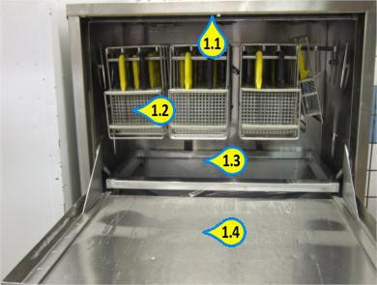**Key Inspection Points**

* 1. Framework
  2. Internal Surfaces
  3. Tank
  4. Door

**Photo No.**  2

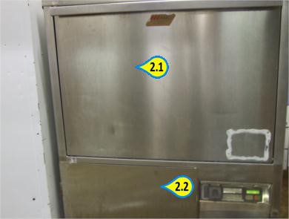**Key Inspection Points**

* 1. Door
  2. External Surfaces

Area - Description

Responsibility For Cleaning

Engineering Assistance Req.

Responsibility For Inspection

Wholesale Butchery - Lazy Sue

Hygiene Operative

Yes

Hygiene Supervisor

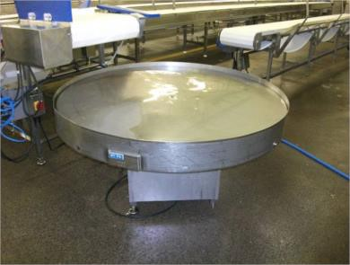

|  |  |  |
| --- | --- | --- |
| **USE PRODUCT COLOUR MINIMUM USE RATE**  **NAME CODE CONTACT** |  | **CLEANING TOOLS REQUIRED** |



**SPECIAL PRECAUTIONS**

1. **Chlorfoam Plus** to be replaced with **Holfoam Acid** on a weekly basis when instructed by the Hygiene Manager.

## DAILY CLEANING METHOD

1. Switch off and isolate the machine from the power supply.
2. Dry wipe over control panels, plugs, sockets and other electrical components with **Protect Active Wipes** and then cover the electrics to waterproof with clean polythene, ensuring it is tied or made water resistant.
3. Remove any gross debris and place in a grey / red colour coded tray for category 2 waste or a tray marked category 2 floor waste tray and then into a category 2 waste dolav.
4. Apply **Chlorfoam Plus** detergent foam solution to all surfaces ensuring an even coverage.
5. Allow a minimum of 20 minutes contact time.
6. Whilst **Chlorfoam Plus** detergent solution is in contact, scrub any stubborn soiling using a designated blue scrubbing brush for the area.
7. Pay particular attention to top, framework and undersides.
8. Visually inspect to ensure all surfaces are clean and free from debris.
9. Reclean if necessary.
10. Spray disinfect all surfaces with **Active** solution.
11. Allow a minimum of 15 minutes contact time.
12. Remove polythene covers from electrical components and re-wipe with **Protect Active Wipes**.
13. Ensure document HYGBU/001 (Butchery Daily Hygiene Pre Op Sheet) is completed at the end of the shift.

**DAILY CLEANING METHOD**

## MONTHLY CLEANING METHOD

1. Switch off and isolate the machine from the power supply.
2. Dry wipe over control panels, plugs, sockets and other electrical components with **Protect Active Wipes** and then cover electrics to waterproof with clean polythene ensuring it is tied or made water resistant.
3. Engineers to remove / open any motor and electrical covers to expose any hidden motors, control panels and water sensitive equipment.
4. Remove any gross debris and place into grey / red colour coded tray for category 2 waste or a tray marked category 2 floor waste tray and then into a category 2 waste dolav.
5. Hand clean any motors, chains, motor housing, covers and seals of the units using **Protect Active Wipes**.
6. Visually inspect to ensure all surfaces are clean and free from debris.
7. Reclean if necessary.
8. Engineers to replace / close covers.
9. Cover panel, motor waterproof with clean polythene, ensuring it is tied or made water Water resistant prior to cleaning equipment.
10. After cleaning equipment remove polythene.
11. Ensure document HYGBU/001 (Butchery Daily Hygiene Pre Op Sheet) is completed at the end of the shift.

**Photo No.**  1

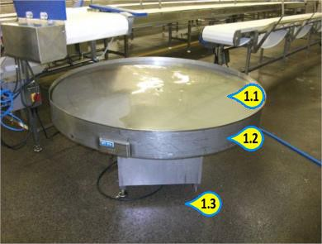**Key Inspection Points**

* 1. Top
  2. Framework
  3. Undersides

Area - Description

Responsibility For Cleaning

Engineering Assistance Req.

Responsibility For Inspection

Wholesale Butchery - Gas Flush Sealer x 3

Hygiene Operative

Yes

Hygiene Supervisor

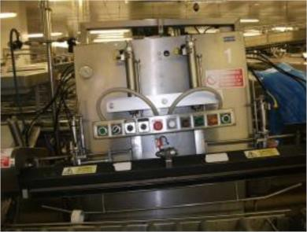

|  |  |  |
| --- | --- | --- |
| **USE PRODUCT COLOUR MINIMUM USE RATE**  **NAME CODE CONTACT** |  | **CLEANING TOOLS REQUIRED** |



**ACTIVE**

**PROFESSIONAL**

**WIPES**

**Disinfectant**

**As Supplied**



**-**

**OTHER CONTROLS**

**PERSONAL PROTECTIVE EQUIPMENT**



## DAILY CLEANING METHOD

1. Switch off and isolate the machine from the power supply.
2. Dry wipe over control panels, plugs, sockets and other electrical components with **Protect Active Wipes.**
3. Remove any excess film from the machine.
4. Open guards and covers to access internal surfaces.
5. Remove any gross debris and place in a grey / red colour coded tray for category 2 waste or a tray marked category 2 floor waste tray and then into a category 2 waste dolav.
6. Hand clean all surfaces using **Protect Active Wipes**. Pay particular attention to sealing head, internal surfaces, guards, conveyor, rollers, framework and undersides. Visually inspect to ensure all surfaces are clean and free from debris. Reclean if necessary.
7. Ensure document HYGBU/001 (Butchery Daily Hygiene Pre Op Sheet) is completed at the end of the shift.

## MONTHLY CLEANING METHOD

1. Switch off and isolate machine from power supply.
2. Dry wipe over control panels, plugs, sockets and other electrical components with **Protect Active Wipes** and then cover the electrics to waterproof with clean polythene ensuring it is tied or made water resistant.
3. Engineers to remove / open any motor and electrical covers to expose any hidden motors, control panels and water sensitive equipment.
4. Remove any gross debris and place into grey / red colour coded tray for category 2 waste or tray marked category 2 floor waste tray and then into a category 2 waste dolav.
5. Hand clean any motors, chains, motor housing, rear surfaces, covers and seals of the units carefully with **Protect Active Wipes**. Visually inspect to ensure all surfaces are clean and free from debris. Reclean if necessary.
6. Engineers to replace / close covers.
7. Cover panel / motor waterproof with clean polythene, ensuring it is tied or made water resistant prior to cleaning equipment.
8. After cleaning equipment remove polythene.
9. Ensure document HYGBU/001 (Butchery Daily Hygiene Pre Op Sheet) is completed at end of shift.

**Photo No.**  1

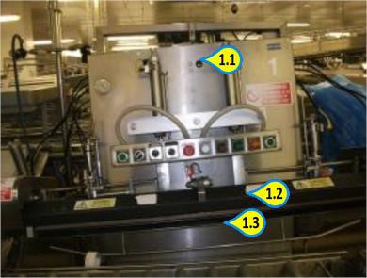**Key Inspection Points**

* 1. Framework
  2. Sealing Head
  3. Undersides

**Photo No.**  2

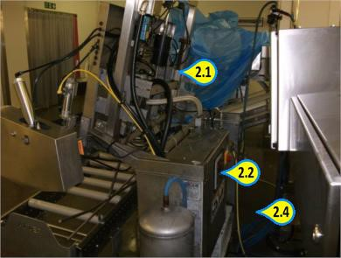**Key Inspection Points**

* 1. Rear Surfaces and Framework
  2. Rear Surfaces

2.4 Undersides

**Photo No.**  3

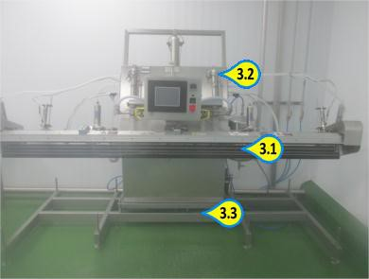**Key Inspection Points**

* 1. Sealing Head
  2. Framework
  3. Undersides

**Photo No.**  4

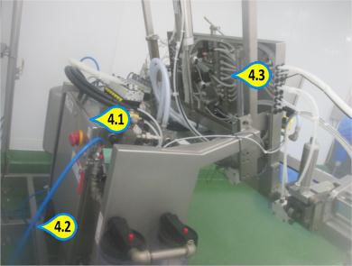**Key Inspection Points**

* 1. Rear Surfaces and Framework
  2. Undersides
  3. Framework and Pipework

|  |  |
| --- | --- |
|  | **SPECIAL PRECAUTIONS** |
| 1. | Blades to be removed by Production or Engineering Operatives. |
| 2. | When Product, Hygiene or Engineering remove nuts and bolts or any other small items then they must be placed into designated container so the small parts do not become lost. |
| 3. | **Chlorfoam Plus** to be replaced with **Holfoam Acid** on a weekly basis when instructed by Hygiene Manager. |
|  | **DAILY CLEANING METHOD** |
| 1. | Switch off and isolate the machine from the power supply. |
| 2. | Remove any gross debris and place in a grey / red colour coded tray for category 2 waste or a tray marked category 2 floor waste tray and then into a category 2 waste dolav. |
| 3. | Production to carry out full strip down. |
| 4. | Production to lift main cover and remove roller, blade and stripper assembly. |
| 5. | Remove any gross debris and place in a suitable waste container. |
| 6. | Rinse all surfaces using fresh clean water to remove any remaining debris. |
| 7. | Apply **Chlorfoam Plus** detergent foam solution to all surfaces ensuring an even coverage. |
| 8. | Allow a minimum of 20 minutes contact time. |
| 1. Whilst **Chlorfoam Plus** detergent solution is in contact, scrub any stubborn soiling using a designated blue scrubbing brush for the area. 2. Pay particular attention to conveyors, rollers, end rollers, blades, stripper assembly, gripper, framework and undersides. 3. Rinse all surfaces thoroughly using fresh clean water. 4. Visually inspect to ensure all surfaces are clean and free from debris. 5. Reclean if necessary. 6. Spray disinfect all surfaces using **Active** solution. | |

Area - Description

Responsibility For Cleaning

Engineering Assistance Req.

Responsibility For Inspection

Wholesale Butchery - Townsend Derinder x 2

Hygiene Operative

Yes

Hygiene Supervisor

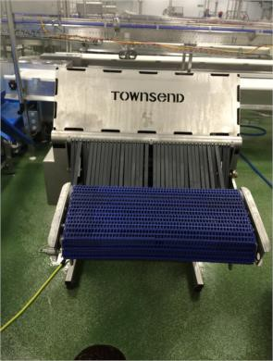

|  |  |  |
| --- | --- | --- |
| **USE PRODUCT COLOUR MINIMUM USE RATE**  **NAME CODE CONTACT** |  | **CLEANING TOOLS REQUIRED** |



## DAILY CLEANING METHOD

1. Allow a minimum 15 minutes contact time.
2. Remove polythene covers from electrical components and re-wipe **Protect Active Wipes**.
3. Ensure document HYGBU/001 (Butchery Daily Hygiene Pre Op Sheet) is completed at the end of the shift.
4. Production to reassemble.

## MONTHLY CLEANING METHOD

1. Switch off and isolate machine from power supply.
2. Dry wipe over control panels, plugs, sockets and other electrical components with **Protect Active Wipes** and then cover the electrics to waterproof with clean polythene ensuring it is tied or made water resistant.
3. Engineers to remove / open any motor and electrical covers to expose any hidden motors, control panels and water sensitive equipment.
4. Remove any gross debris and place into grey / red colour coded tray for category 2 waste or tray marked category 2 floor waste tray and then into a category 2 waste dolav.
5. Hand clean any motors, chains, motor housing, rear surfaces, covers and seals of the units carefully with **Protect Active Wipes.**
6. Visually inspect to ensure all surfaces are clean and free from debris.
7. Reclean if necessary.
8. Engineers to replace / close covers.
9. Cover panel / motor waterproof with clean polythene, ensuring it is tied or made water resistant prior to cleaning equipment.
10. After cleaning equipment remove polythene.
11. Ensure document HYGBU/001 (Butchery Daily Hygiene Pre Op Sheet) is completed at end of shift.

1.1

1.2

1.3

**Photo No.**

1

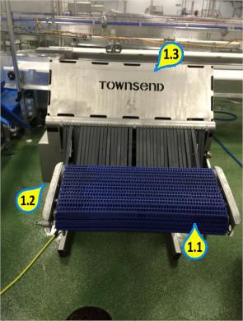

Belt

Framework and undersides

External surfaces

**Key Inspection Points**

2.1

2.2

2.3

2.4

**Photo No.**

2

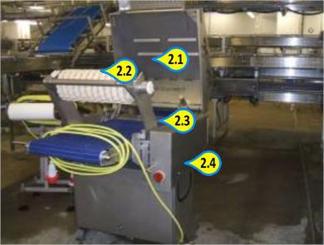

Cover

Rollers

Stripper Assembly

Framework

**Key Inspection Points**

3.1

**Photo No.**

3

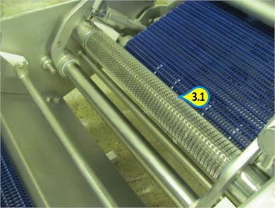

Stripper Assembly

**Key Inspection Points**

**Photo No.**  4

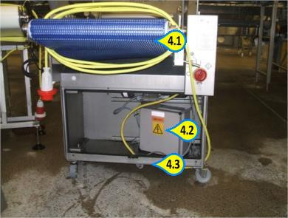**Key Inspection Points**

* 1. Conveyor Belt
  2. Motor Housing
  3. Undersides

**Photo No.**  5

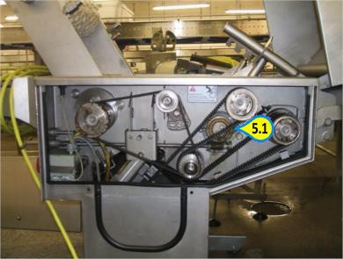**Key Inspection Points**

5.1 Chains and Drives

Area - Description

Responsibility For Cleaning

Engineering Assistance Req.

Responsibility For Inspection

Wholesale Butchery - Webber Autofeed Derinder

Hygiene Operative

Yes

Hygiene Supervisor

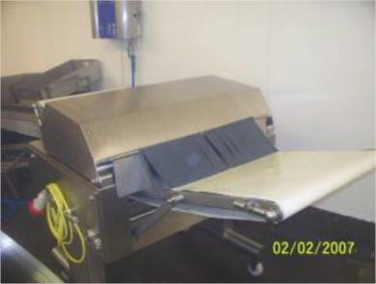

|  |  |  |
| --- | --- | --- |
| **USE PRODUCT COLOUR MINIMUM USE RATE**  **NAME CODE CONTACT** |  | **CLEANING TOOLS REQUIRED** |



|  |  |
| --- | --- |
|  | **SPECIAL PRECAUTIONS** |
| 1. | Blades to be removed by Production / Engineering Operatives. |
| 2. | When Product, Hygiene or Engineering; remove nuts and bolts or any other small items then they must be placed into designated container so the small parts do not become lost. |
| 3. | **Chlorfoam Plus** to be replaces with **Holfoam Acid** on a weekly basis when instructed by Hygiene Manager. |
|  | **DAILY CLEANING METHOD** |
| 1. | Switch off and isolate the machine from the power supply. |
| 2. | Remove any gross debris and place in a grey / red colour coded tray for category 2 waste or a tray marked category 2 floor waste tray and then into a category 2 waste dolav. |
| 3. | Production to carry out full strip down. |
| 4. | Production to lift main cover and remove roller, blade and stripper assembly. |
| 5. | Remove any gross debris and place in a suitable waste container. |
| 6. | Rinse all surfaces using fresh clean water to remove any remaining debris. |
| 7. | Apply **Chlorfoam Plus** detergent foam solution to all surfaces ensuring an even coverage. |
| 8. | Allow a minimum of 20 minutes contact time. |
| 1. Whilst **Chlorfoam Plus** detergent solution is in contact, scrub any stubborn soiling using a designated blue scrubbing brush for the area. 2. Pay particular attention to conveyors, rollers, end rollers, blades, stripper assembly, gripper, framework and undersides. 3. Rinse all surfaces thoroughly using fresh clean water. 4. Visually inspect to ensure all surfaces are clean and free from debris. 5. Reclean if necessary. 6. Spray disinfect all surfaces using **Active** solution. | |

## DAILY CLEANING METHOD

1. Allow a minimum 15 minutes contact time.
2. Remove polythene covers from electrical components and re-wipe with **Protect Active Wipes**.
3. Ensure document HYGBU/001 (Butchery Daily Hygiene Pre Op Sheet) is completed at the end of the shift.
4. Production to reassemble.

## MONTHLY CLEANING METHOD

1. Switch off and isolate machine from power supply.
2. Dry wipe over control panels, plugs, sockets and other electrical components with **Protect Active Wipes** and then cover electrics to waterproof with clean polythene ensuring it is tied or made water resistant.
3. Engineers to remove / open any motor and electrical covers to expose any hidden motors, control panels and water sensitive equipment.
4. Remove any gross debris and place into grey / red colour coded tray for category 2 waste or a tray marked category 2 floor waste tray then into a category 2 waste dolav.
5. Hand clean any motors, chains motor housing, covers and seals of units carefully with **Protect Active Wipes**.
6. Visually inspect to ensure all surfaces are clean and free from debris.
7. Reclean if necessary.
8. Engineers to replace / close covers.
9. Cover panel / motor waterproof with clean polythene ensuring it is tied or made water resistant prior to cleaning equipment.
10. After cleaning equipment remove polythene.
11. Ensure document HYGBU/001 (Butchery Daily Hygiene Pre Op Sheet) is completed at end of shift.

**Photo No.**  1

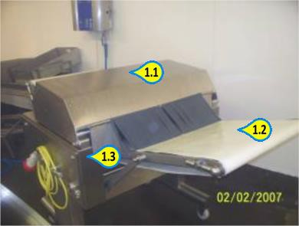**Key Inspection Points**

* 1. Cover
  2. Conveyor Belt
  3. Framework

**Photo No.**  2

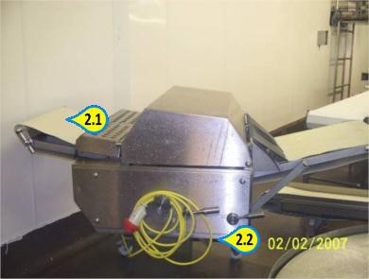**Key Inspection Points**

* 1. Rollers
  2. Undersides

**Photo No.**  3

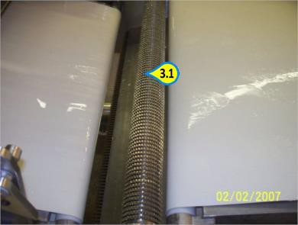**Key Inspection Points**

3.1 Stripper Assembly

**Photo No.**  4

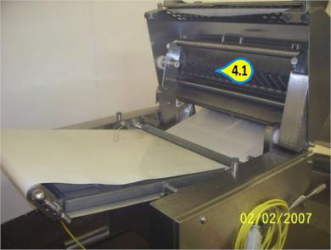**Key Inspection Points**

4.1 Undersides of Cover

**Photo No.**  5

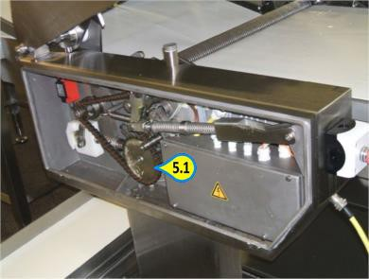**Key Inspection Points**

5.1 Chains and Drives

Area - Description

Responsibility For Cleaning

Engineering Assistance Req.

Responsibility For Inspection

Wholesale Butchery - Grasselli Autofeed Skinner

Hygiene Operative

Yes

Hygiene Supervisor

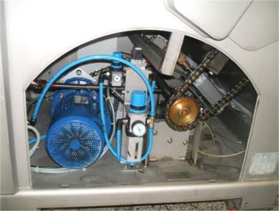

|  |  |  |
| --- | --- | --- |
| **USE PRODUCT COLOUR MINIMUM USE RATE**  **NAME CODE CONTACT** |  | **CLEANING TOOLS REQUIRED** |

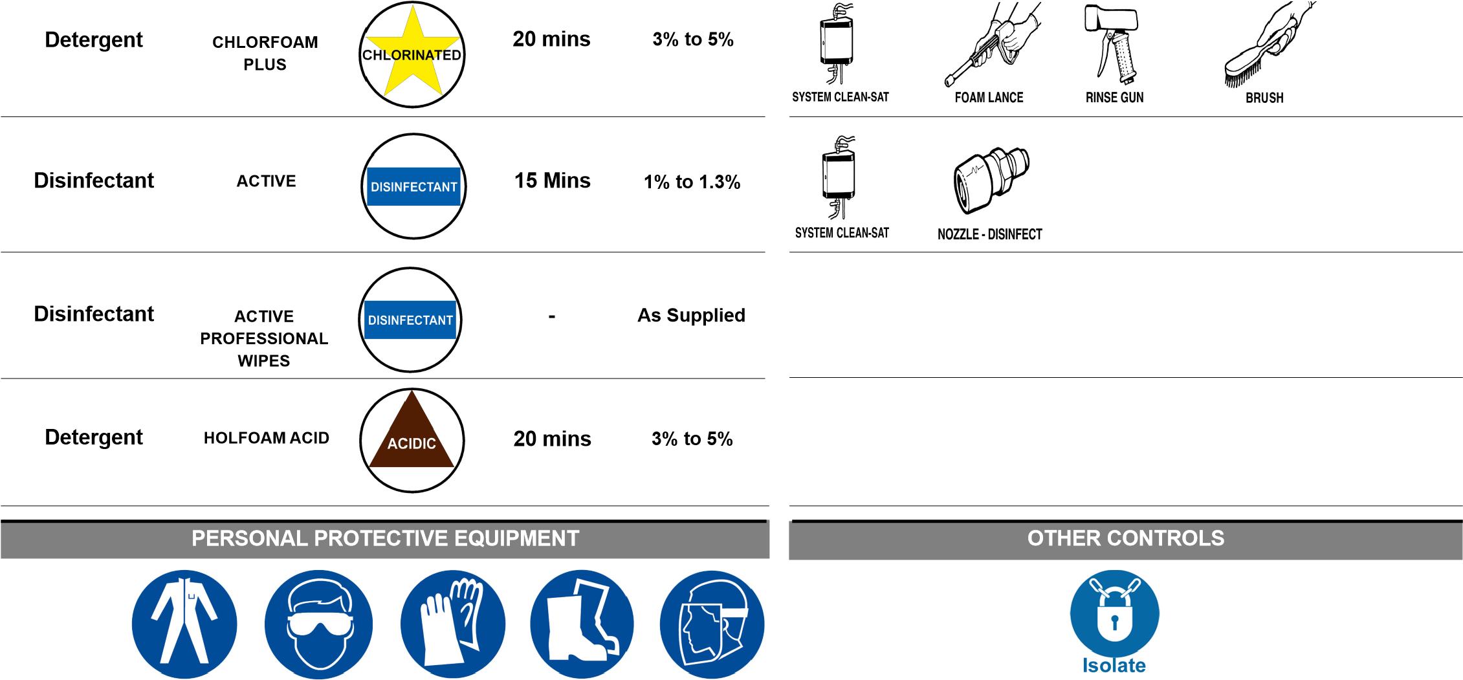

## SPECIAL PRECAUTIONS

1. Blades to be removed by Production or Engineering Operatives.
2. When Production, Hygiene or Engineering remove nuts and bolts or any other small items then they must be placed into designated container so the small parts do not become lost.
3. **Chlorfoam Plus** to be replaced with **Holfoam Acid** on a weekly basis when instructed by Hygiene Manager.

## DAILY CLEANING METHOD

1. Switch off and isolate the machine from the power supply.
2. Remove any gross debris and place in a grey / red colour coded tray for category 2 waste or a tray marked category 2 floor waste tray and then into a category 2 waste dolav.
3. Production to carry out full strip down.
4. Production to lift main cover and remove roller, blade and stripper assembly.
5. Remove any gross debris and place in a suitable waste container.
6. Rinse all surfaces using fresh clean water to remove any remaining debris.
7. Apply **Chlorfoam Plus** detergent foam solution to all surfaces ensuring an even coverage.
8. Allow a minimum of 20 minutes contact time.
9. Whilst **Chlorfoam Plus** detergent solution is in contact, scrub any stubborn soiling using a designated blue scrubbing brush for the area.
10. Pay particular attention to conveyors, rollers, end rollers, blades, stripper assembly, gripper, framework and undersides.
11. Rinse all surfaces thoroughly using fresh clean water.
12. Visually inspect to ensure all surfaces are clean and free from debris.
13. Reclean if necessary.
14. Spray disinfect all surfaces using **Active** solution.

## DAILY CLEANING METHOD

1. Allow a minimum 15 minutes contact time.
2. Remove polythene covers from electrical components and re-wipe with **Protect Active Wipes.**
3. Ensure document HYGBU/001 (Butchery Daily Hygiene Pre Op Sheet) is completed at the end of the shift.
4. Production to reassemble.

## MONTHLY CLEANING METHOD

1. Switch off and isolate machine from power supply.
2. Dry wipe over control panels, plugs, sockets and other electrical components with **Protect Active Wipes** and then cover the electrics to waterproof with clean polythene ensuring it is tied or made water resistant.
3. Engineers to remove / open any motor and electrical covers to expose any hidden motors, control panels and water sensitive equipment.
4. Remove any gross debris and place into grey / red colour coded tray for category 2 waste or tray marked category 2 floor waste tray and then into a category 2 waste dolav.
5. Hand clean any motors, chains, motor housing, rear surfaces, covers and seals of the units carefully with **Protect Active Wipes.** Visually inspect to ensure all surfaces are clean and free from debris. Reclean if necessary.
6. Engineers to replace / close covers.
7. Cover panel / motor waterproof with clean polythene, ensuring it is tied or made water resistant prior to cleaning equipment.
8. After cleaning equipment remove polythene.
9. Ensure document HYGBU/001 (Butchery Daily Hygiene Pre Op Sheet) is completed at end of shift.

**Photo No.**  1

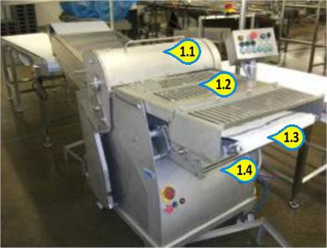**Key Inspection Points**

* 1. Covers
  2. Covers
  3. Framework
  4. Undersides

**Photo No.**  2

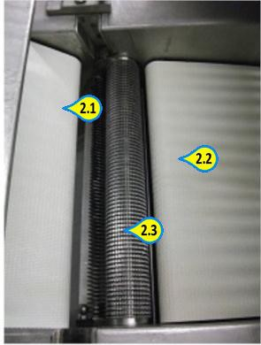**Key Inspection Points**

* 1. Conveyor Belts
  2. Conveyor Belts
  3. Roller and Grabber

**Photo No.**  3

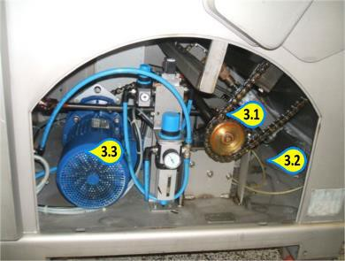**Key Inspection Points**

* 1. Chain and Drive
  2. Internal Surfaces
  3. Motor and Motor Housing

B18/0

**LINK CORRIDOR**

Page 1 of 2

Area - Description

Responsibility For Cleaning

Engineering Assistance Req.

Responsibility For Inspection

Wholesale Butchery - Link Corridor

Hygiene Operative

No

Hygiene Supervisor

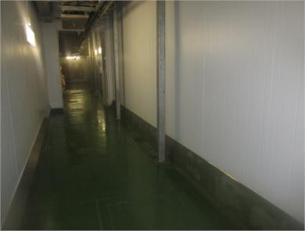

|  |  |  |
| --- | --- | --- |
| **USE PRODUCT COLOUR MINIMUM USE RATE**  **NAME CODE CONTACT** |  | **CLEANING TOOLS REQUIRED** |



**CHLORFOAM**

**PLUS**

**Detergent**

**2**

**% to 3%**

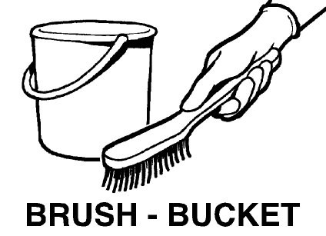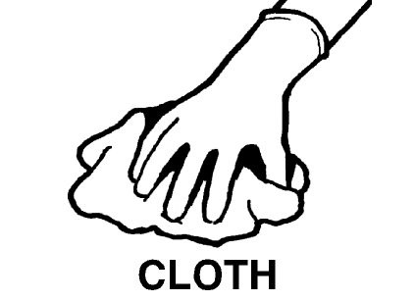

**-**

**OTHER CONTROLS**

**PERSONAL PROTECTIVE EQUIPMENT**



## DAILY CLEANING METHOD

1. Sweep the floor area, collect debris and discard into an appropriate waste container.
2. Remove drain cover and empty waste into an appropriate waste container.
3. Foam all floor surfaces, walls, pillars and drain with **Chlorfoam Plus** detergent solution.
4. Hand pad the pillars to ensure that they are clean.
5. Rinse away solution and squeegee floor dry.
6. Inspect drain for cleanliness and if any debris remains, remove and re-clean.
7. Visually inspect to ensure all surfaces are clean and free from debris.
8. Reclean if necessary.

|  |
| --- |
| Cleaning Instruction Card © |
| **LINK CORRIDOR** |

B18/0

Page 2 of 2

**Photo No.**  1

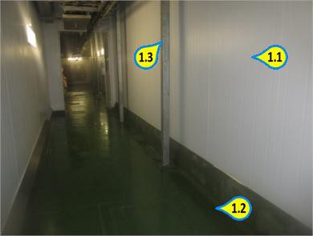**Key Inspection Points**

* 1. Walls
  2. Floor
  3. Pillars

Area - Description

Responsibility For Cleaning

Engineering Assistance Req.

Responsibility For Inspection

Wholesale Butchery - Vanguard Derinder x 2

Hygiene Operative

Yes

Hygiene Supervisor

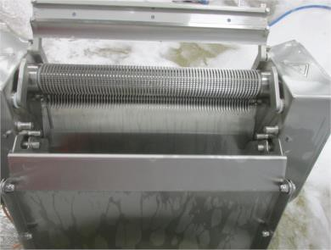

|  |  |  |
| --- | --- | --- |
| **USE PRODUCT COLOUR MINIMUM USE RATE**  **NAME CODE CONTACT** |  | **CLEANING TOOLS REQUIRED** |



|  |  |
| --- | --- |
|  | **SPECIAL PRECAUTIONS** |
| 1. | Blades to be removed by Production or Engineering Operatives. |
| 2. | When Product, Hygiene or Engineering remove nuts and bolts or any other small items then they must be placed into designated container so the small parts do not become lost. |
| 3. | **Chlorfoam Plus** to be replaced with **Holfoam Acid** on a weekly basis when instructed by Hygiene Manager. |
|  | **DAILY CLEANING METHOD** |
| 1. | Switch off and isolate the machine from the power supply. |
| 2. | Remove any gross debris and place in a grey / red colour coded tray for category 2 waste or a tray marked category 2 floor waste tray and then into a category 2 waste dolav. |
| 3. | Production to carry out full strip down. |
| 4. | Production to lift main cover and remove roller, blade and stripper assembly. |
| 5. | Remove any gross debris and place in a suitable waste container. |
| 6. | Rinse all surfaces using fresh clean water to remove any remaining debris. |
| 7. | Apply **Chlorfoam Plus** detergent foam solution to all surfaces ensuring an even coverage. |
| 8. | Allow a minimum of 20 minutes contact time. |
| 1. Whilst **Chlorfoam Plus** detergent solution is in contact, scrub any stubborn soiling using a designated blue scrubbing brush for the area. 2. Pay particular attention to conveyors, rollers, end rollers, blades, stripper assembly, gripper, framework and undersides. 3. Rinse all surfaces thoroughly using fresh clean water. 4. Visually inspect to ensure all surfaces are clean and free from debris. 5. Reclean if necessary. 6. Spray disinfect all surfaces using **Active** solution. | |

## DAILY CLEANING METHOD

1. Allow a minimum 15 minutes contact time.
2. Remove polythene covers from electrical components and re-wipe **Protect Active Wipes**.
3. Ensure document HYGBU/001 (Butchery Daily Hygiene Pre Op Sheet) is completed at the end of the shift.
4. Production to reassemble.

## MONTHLY CLEANING METHOD

1. Switch off and isolate machine from power supply.
2. Dry wipe over control panels, plugs, sockets and other electrical components with **Protect Active Wipes** and then cover the electrics to waterproof with clean polythene ensuring it is tied or made water resistant.
3. Engineers to remove / open any motor and electrical covers to expose any hidden motors, control panels and water sensitive equipment.
4. Remove any gross debris and place into grey / red colour coded tray for category 2 waste or tray marked category 2 floor waste tray and then into a category 2 waste dolav.
5. Hand clean any motors, chains, motor housing, rear surfaces, covers and seals of the units carefully with **Protect Active Wipes.**
6. Visually inspect to ensure all surfaces are clean and free from debris.
7. Reclean if necessary.
8. Engineers to replace / close covers.
9. Cover panel / motor waterproof with clean polythene, ensuring it is tied or made water resistant prior to cleaning equipment.
10. After cleaning equipment remove polythene.
11. Ensure document HYGBU/001 (Butchery Daily Hygiene Pre Op Sheet) is completed at end of shift.

**Photo No.**  1

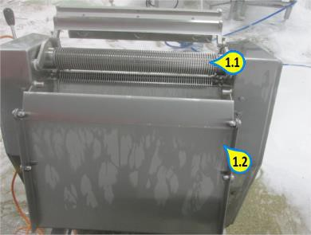**Key Inspection Points**

* 1. Tooth roller
  2. Framework

**Photo No.**  2

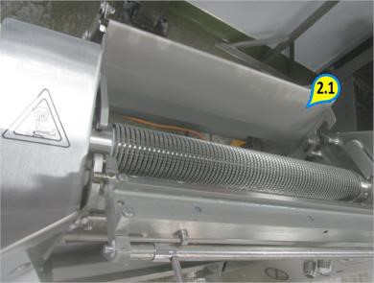**Key Inspection Points**

2.1 Guard

**Photo No.**  3

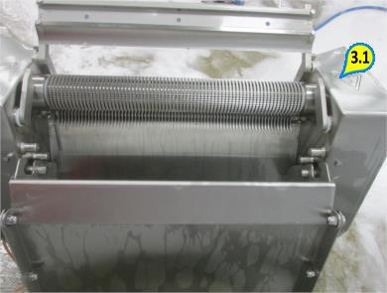**Key Inspection Points**

3.1 Side panels

Area - Description

Responsibility For Cleaning

Engineering Assistance Req.

Responsibility For Inspection

Wholesale Butchery - Vanguard Skinner

Hygiene Operative

Yes

Hygiene Supervisor

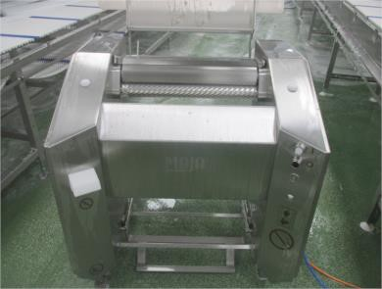

|  |  |  |
| --- | --- | --- |
| **USE PRODUCT COLOUR MINIMUM USE RATE**  **NAME CODE CONTACT** |  | **CLEANING TOOLS REQUIRED** |



## SPECIAL PRECAUTIONS

1. Blades to be removed by Production or Engineering Operatives.
2. When Production, Hygiene or Engineering remove nuts and bolts or any other small items then they must be placed into designated container so the small parts do not become lost.
3. **Chlorfoam Plus** to be replaced with **Holfoam Acid** on a weekly basis when instructed by Hygiene Manager.

## DAILY CLEANING METHOD

1. Switch off and isolate the machine from the power supply.
2. Remove any gross debris and place in a grey / red colour coded tray for category 2 waste or a tray marked category 2 floor waste tray and then into a category 2 waste dolav.
3. Production to carry out full strip down.
4. Production to lift main cover and remove roller, blade and stripper assembly.
5. Remove any gross debris and place in a suitable waste container.
6. Rinse all surfaces using fresh clean water to remove any remaining debris.
7. Apply **Chlorfoam Plus** detergent foam solution to all surfaces ensuring an even coverage.
8. Allow a minimum of 20 minutes contact time.
9. Whilst **Chlorfoam Plus** detergent solution is in contact, scrub any stubborn soiling using a designated blue scrubbing brush for the area.
10. Pay particular attention to conveyors, rollers, blades, stripper assembly, gripper, framework and undersides.
11. Rinse all surfaces thoroughly using fresh clean water.
12. Visually inspect to ensure all surfaces are clean and free from debris.
13. Reclean if necessary.
14. Spray disinfect all surfaces using **Active** solution.

## DAILY CLEANING METHOD

1. Allow a minimum 15 minutes contact time.
2. Remove polythene covers from electrical components and re-wipe with **Protect Active Wipes.**
3. Ensure document HYGBU/001 (Butchery Daily Hygiene Pre Op Sheet) is completed at the end of the shift.
4. Production to reassemble.

## MONTHLY CLEANING METHOD

1. Switch off and isolate machine from power supply.
2. Dry wipe over control panels, plugs, sockets and other electrical components with **Protect Active Wipes** and then cover the electrics to waterproof with clean polythene ensuring it is tied or made water resistant.
3. Engineers to remove / open any motor and electrical covers to expose any hidden motors, control panels and water sensitive equipment.
4. Remove any gross debris and place into grey / red colour coded tray for category 2 waste or tray marked category 2 floor waste tray and then into a category 2 waste dolav.
5. Hand clean any motors, chains, motor housing, rear surfaces, covers and seals of the units carefully with **Protect Active Wipes.** Visually inspect to ensure all surfaces are clean and free from debris. Reclean if necessary.
6. Engineers to replace / close covers.
7. Cover panel / motor waterproof with clean polythene, ensuring it is tied or made water resistant prior to cleaning equipment.
8. After cleaning equipment remove polythene.
9. Ensure document HYGBU/001 (Butchery Daily Hygiene Pre Op Sheet) is completed at end of shift.

1.1

1.2

1.3

**Photo No.**

1

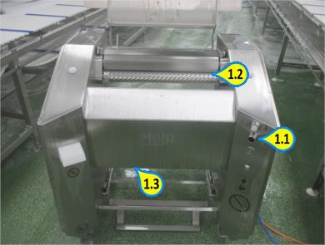

Control buttons

Blade rollers

Framework and undersides

**Key Inspection Points**

2.1

2.2

**Photo No.**

2

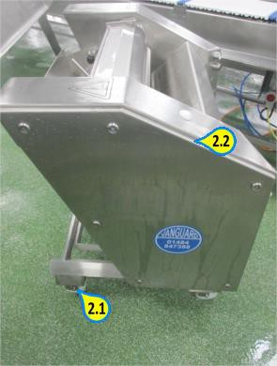

Wheels

Framework

**Key Inspection Points**

3.1

3.2

**Photo No.**

3

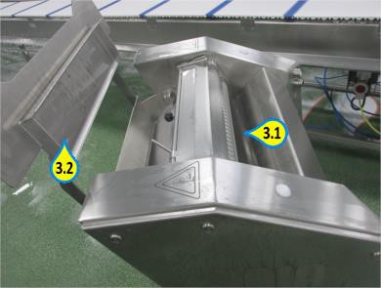

Infeed area

Framework

**Key Inspection Points**